Conference Program

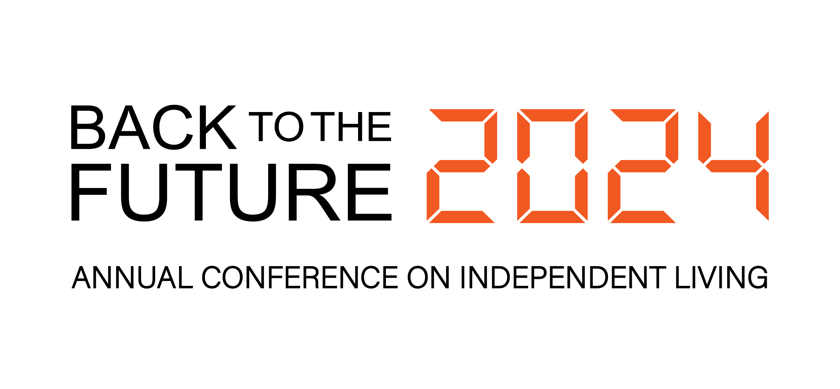
Conference Logo: Black sans serif text says, “BACK TO THE FUTURE”. To the right, digital font in bright, bold orange says, “2024”. Underneath, Annual Conference on Independent Living.

Presented by the National Council on Independent Living

Table of Contents

Conference Program 1
Table of Contents 2
Hill Report Form 3
A Message from the Executive Director 3
Agenda 5
Schedule of Events 8
About Workshop Sessions 19
Speakers 60
Annual Council Meeting Agenda 66
Map of Independence Level (5B) 69
Restrooms 70
Health & Safety Protocols 70
Onsite Registration 71
NCIL Regions by State 71
Do-It-Yourself Sign Kits 73
What to Bring 74
Access, Accommodations, & Resources 75
Advocate’s Guide to the Hill 78
Sponsors 86
Advertisements 87

Hill Report Form

After your Hill Visits, submit your Hill Report Form at surveymonkey.com/r/ncil2024.

A Message from the Executive Director

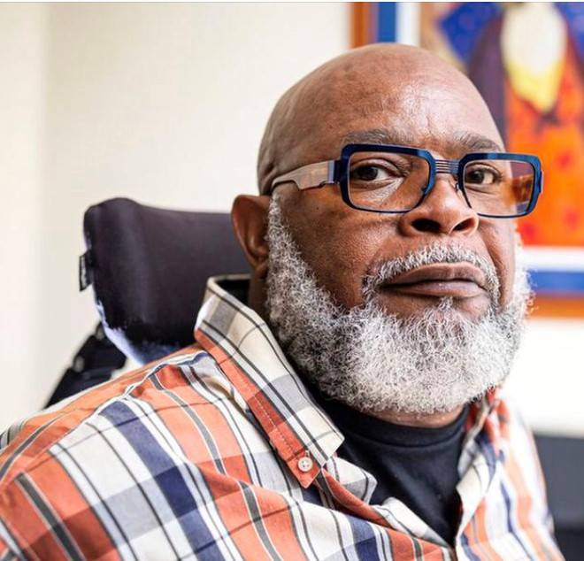

Why did NCIL select "Back to the Future" as this year's theme? Is it just a play on a popular 80s movie, or is there something more? It’s both, but the deeper significance is crucial. We look back at our past to avoid repeating our mistakes.

We learn from our history, both the good and the ugly. We reflect on the positive aspects to build upon and improve them. We reflect on the negative aspects to avoid those missteps and grow wiser from them.

This is why we chose this theme. Please attend this year’s conference with this perspective in mind. We did our best to keep this perspective as we planned the entire conference.

For example, this year, for the first time, we are learning from our past not to work in silos. We are collaborating with the National Association of Councils on Developmental Disabilities (NACDD), who are joining us during their own conference.

NCIL and NACDD recognized that we have shared priorities and are stronger together. It takes strong leaders and visionaries to see that we are more alike than unalike.

The NCIL board, staff, and members thank NACDD and challenge other organizations to recognize that collectively, we can achieve bigger and greater things.

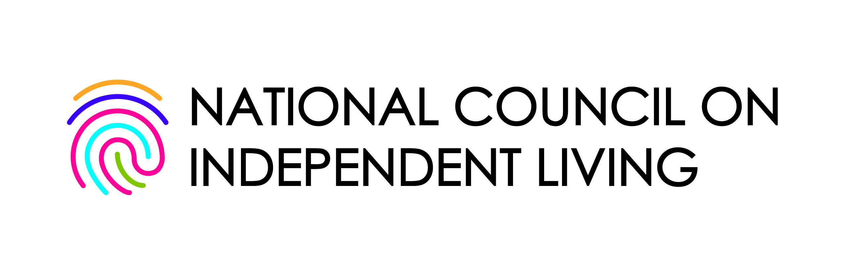

You will also notice that we have unveiled a new logo for the organization. The colors in the logo speak to the diversity of our community. The fingerprint speaks to our uniqueness as individuals and organizations. It reminds us that consumer control is at the heart of everything we do.

I would also like to extend our sincerest thanks to our conference sponsors: Centene; CareSource; the Nevada Statewide Independent Living Council; Dignity Memorial; Waymo; Verizon; Esquire Bank; UnitedHealthcare; Airbnb; CIL Suite; ADA National Network; PhRMA; and Cruise.

We look forward to this year's conference as we go Back to the Future!

Theo Braddy

Executive Director

Use our hashtag!

#NCIL2024

Agenda

Sunday, July 21

- 1:00 p.m. – 5:00 p.m.: Board Meeting (Farragut + Lafayette)

Monday, July 22

- 9:00 a.m. – 10:15 a.m.: Opening Plenary (Independence A)
- 10:30 a.m. – 10:45 a.m.: Advocacy Updates (Independence A)
- 10:45 a.m. – 11:45 a.m.: Regional Caucuses (Independence A)
- 2:25 p.m. – 4:00 p.m.: March to the Capitol: MARCH ON! (G + 11th Streets NW)
- 4:00 p.m. – 5:00 p.m.: 2024 Rally at the Capitol (U.S. Capitol)

Tuesday, July 23

- 9:00 a.m. – 10:15 a.m.: Concurrent Workshops 1 (various locations)
- 10:15 a.m. – 12:00 p.m.: Exhibit Fair & Sponsored Coffee Break (Independence A / Foyer)
- 12:00 p.m. – 2:00 p.m.: Awards Luncheon (Independence Ballroom)
- 2:15 p.m. – 3:00 p.m.: Annual Council Meeting (Independence Ballroom)
- 3:30 p.m. – 5:00 p.m.: D, E, A, & I: What Do They Mean and How Are They Seen? (Independence Ballroom)
- 5:30 p.m. – 8:30 p.m.: Headshots (Independence Foyer; Reservation Required)
- 8:00 p.m. – 9:00 p.m.: Reception / Social Hour (Independence Ballroom)
- 9:00 p.m. – 11:00 p.m.: NCIL@NITE (Independence Ballroom)

Wednesday, July 24

- 9:00 a.m. – 10:15 a.m.: Concurrent Workshops 2 (various locations)
- 10:30 a.m. – 11:45 a.m.: Concurrent Workshops 3 (various locations)
- 12:00 p.m. – 5:00 p.m.: Hill Visits (U.S. Capitol)

Thursday, July 25

- 9:00 a.m. – 10:15 a.m.: Concurrent Workshops 4 (various locations)
- 10:30 a.m. – 11:45 a.m.: Concurrent Workshops 5 (various locations)
- 1:00 p.m. – 2:00 p.m.: Closing Plenary (Independence A)
- 2:15 p.m. – 5:15 p.m.: Board Meeting (Lafayette + Farragut)

Schedule of Events

SUNDAY, JULY 21

Registration Open

3:00 p.m. – 6:00 p.m. / Location: Independence Foyer

BOARD MEETING

1:00 p.m. – 5:00 p.m. / Location: Farragut + Lafayette

MONDAY, JULY 22

Registration & Exhibits Open

8:00 a.m. – 5:00 p.m. / Location: Independence Foyer

Sensory Retreat / Quiet Space

8:00 a.m. – 6:45 p.m. / Location: McPherson

Multipurpose Room / Dialogue Zone

8:00 a.m. – 6:45 p.m. / Location: Washington Board Room

OPENING PLENARY

9:00 a.m. – 10:15 a.m. / Location: Independence A

Brace yourselves for an opening speech by the awe-inspiring Tony Coelho, the visionary architect of the Americans with Disabilities Act. Tony will join an intergenerational panel of disability justice advocates including Cliff Perez; Keri Gray; and Jim Ward. Speaker biographies are available on Pages 30-31.

ADVOCACY UPDATES

10:30 a.m. – 10:45 a.m. / Location: Independence A

Get up-to-date information on the progress of NCIL’s advocacy efforts from Chairs of NCIL’s Legislative & Advocacy Subcommittees. The Chairs will review and answer questions about NCIL’s policy priorities so participants are fully prepared for their Congressional visits.

REGIONAL CAUCUSES

10:45 a.m. – 11:45 a.m. / Location: Independence A

This is an opportunity for attendees to meet with their Regional Representatives and strategize for their Capitol Hill Visits. Each state decides who will attend which meeting to ensure that every legislator is visited. A list of Regions by state is available at ncil.org/regions.

MARCH TO THE CAPITOL: MARCH ON!

2:15 p.m. – 4:00 p.m. / Location: G + 11th Streets NW

NCIL members march from the Grand Hyatt to Capitol Hill demonstrating support for the independence of people with disabilities! Complimentary Do-It-Yourself Sign Kits will be available on the conference floor the morning of Monday, July 22. Participants should assemble between 2:15 p.m. – 2:45 p.m. at G and 11th Streets, NW. The March will begin promptly at 3:00 p.m.

2024 RALLY AT THE CAPITOL

4:00 p.m. – 5:00 p.m. / Location: U.S. Capitol

Marchers will converge in front of the Capitol Building for an empowering Rally featuring a number of speakers, including leaders in the Independent Living Movement and elected officials working on the issues we care about most. Snacks will be provided to conference registrants upon arrival.

TUESDAY, JULY 23

Registration & Exhibits Open

8:00 a.m. – 5:00 p.m. / Location: Independence Foyer

Sensory Retreat / Quiet Space

8:00 a.m. – 6:30 p.m. / Location: McPherson

Multipurpose Room / Dialogue Zone

8:00 a.m. – 6:45 p.m. / Location: Washington Board Room

CONCURRENT WORKSHOPS I

9:00 a.m. – 10:15 a.m. / Location: Various

- Radial Community: Anti-Racist Organizing through Independent Living (Location: Independence A)
- Revisiting the 12 Independent Living Pillars through a Global and Intersectional Lens (Location: Independence BC)
- Innovation in Technology, Entrepreneurship, and Well-Being (Location: Independence DE)
- How to Build a Successful Youth Program (Location: Independence FGHI)
- Incorporating the State Plan into Your Organizations Plans (Location: Lafayette / Farragut)

EXHIBIT FAIR & SPONSORED COFFEE BREAK

10:15 a.m. – 12:00 p.m. / Location: Independence Foyer + Independence A

Spend some time browsing the products and services offered by our exhibitors, many of which are your fellow NCIL members. The NCIL Conference would not be possible without the generous support of our exhibitors and sponsors. Exhibits will be open all day Monday and Tuesday.


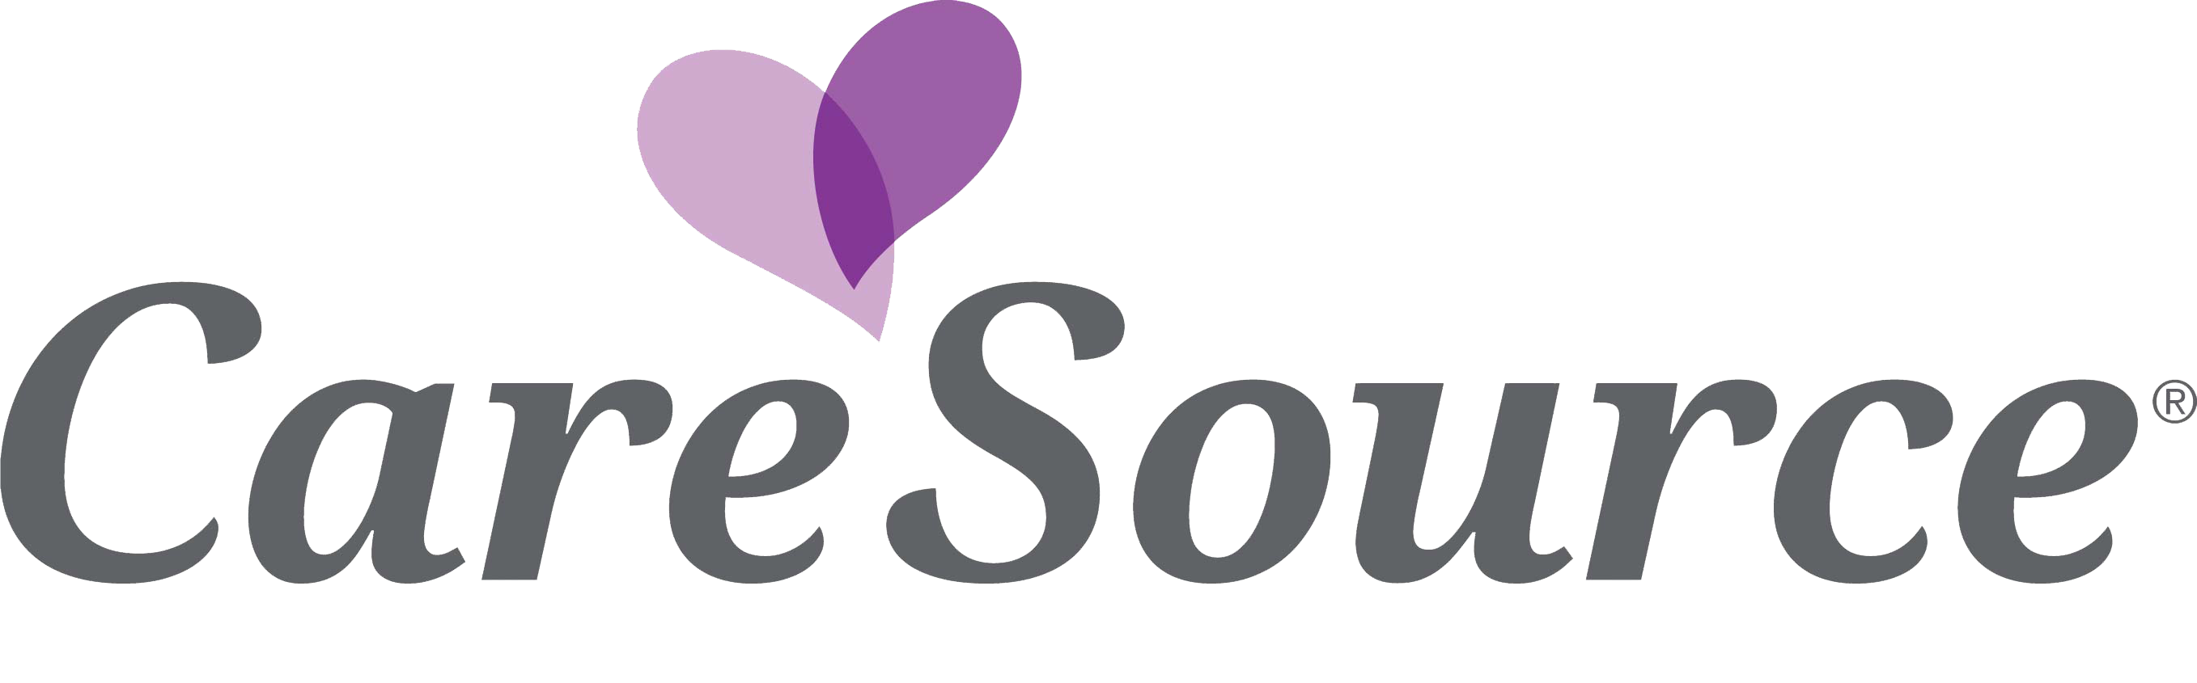


AWARDS LUNCHEON

12:00 p.m. – 2:00 p.m. / Location: Independence Ballroom

Join us to celebrate and honor this year’s national award winners! Awards will be presented over lunch. Participants will have the opportunity to hear from Sherman Gillums, Jr., FEMA’s Disability Coordinator and Director of its Office of Disability Integration and Coordination. Admission to this event is included in full conference registration. Speaker biographies are available on Pages 30-31.

ANNUAL COUNCIL MEETING

2:15 p.m. – 3:00 p.m. / Location: Independence Ballroom

Attend the Annual Council Meeting to hear the results of the elections for Governing Board members. This year, elections were held prior to the conference for: Vice President; Secretary; Diversity, Equity, Accessibility, and Inclusion (DEAI) Chair; three Member At-Large positions; Youth At-Large; and Representatives of Regions II, IV, VI, VIII, X (2, 4, 6, 8 & 10).

D, E, A, & I: WHAT DO THEY MEAN AND HOW ARE THEY SEEN?

3:30 p.m. – 5:00 p.m. / Location: Independence Ballroom

Join us on Tuesday afternoon to learn, discuss under-represented communities in the Independent Living Movement, and talk to each other about our views of diversity, equity, accessibility, and inclusion. This session will start off with a panel discussion featuring IL leaders within under-represented communities. Following, we will break into smaller groups and key in on topics related to each letter of DEAI (Diversity, Equity, Accessibility, and Inclusion). It will be a great opportunity to learn about different views from leaders of the community, and your own IL peer network!

HEADSHOTS

5:30 p.m. – 8:30 p.m. / Location: Independence Foyer

For two hours on Tuesday, you will have the opportunity to have your headshot taken with NCIL’s professional photographer, Andrew Robertson. A reservation is required. Please arrive a few minutes before your scheduled window and be prepared for your shoot. Sessions are expected to take approximately 5 minutes per person. Donations are appreciated and will be split 50/50 between NCIL and the photographer. If you missed your opportunity to reserve a headshot, visit the red carpet in Independence Foyer starting at 9:00 p.m. NCIL will have professional lighting and a volunteer ready to snap photos of individuals and groups.

NCIL RECEPTION

8:00 p.m. – 9:00 p.m. / Location: Independence Ballroom

Join NCIL Staff, Board Members, and fellow attendees for this first hour of networking, food, and drinks. Light snack and non-alcoholic beverages will be available, accompanied by a cash bar.

NCIL@NITE

9:00 p.m. – 11:00 p.m. / Location: Independence Ballroom

Let’s get the celebration started of Independent Living and the NCIL Conference! Right after the NCIL Reception, the dance floor will open up and everyone will have a chance to party like it’s 1999. Join us for an exciting atmosphere and fun-filled evening.

WEDNESDAY, JULY 24

Registration & Exhibits Open

8:00 a.m. – 5:00 p.m. / Location: Independence Foyer

Sensory Retreat / Quiet Space

8:00 a.m. – 6:30 p.m. / Location: McPherson

Multipurpose Room / Dialogue Zone

8:00 a.m. – 6:45 p.m. / Location: Washington Board Room

CONCURRENT WORKSHOPS II

9:00 a.m. – 10:15 a.m. / Location: Various

- Recommitment to IL Values (Location: Independence A)
- Cultivating International Collaboration Among IL Centers Around the World (Location: Independence BC)
- Artificial Intelligence and Why You Should Care: A Conversation About Equitable AI (Location: Independence DE)
- Empowering You(th) in the Journey of Authentic Relationships (Location: Independence FGHI)
- Building Community through Pride (Location: Lafayette / Farragut)

CONCURRENT WORKSHOPS III

10:30 a.m. – 11:45 a.m. / Location: Various

- DME, LTCFS and Healthcare: What Private Equity Has to Do with It – What It Means and How to Combat It (Location: Independence A)
- Engaging the Youth to Unleash the Power of Storytelling in Self-Advocacy (Location: Independence BC)
- Building an Action-Oriented Advocacy Network (Location: Independence DE)
- Creating Your Own Peer Network (Location: Independence FGHI)
- Global Disability-Inclusive Disaster Risk Reduction Strategies (Location: Lafayette / Farragut)

HILL VISITS

12:00 p.m. – 5:00 p.m. / Location: U.S. Capitol

NCIL members are strongly encouraged to go and meet with their elected officials (or set up virtual meetings where necessary) to discuss pressing legislation impacting people with disabilities and Independent Living nationwide.

These meetings must be arranged in advance. Senators and Representatives set their own policies about whether they are meeting with constituents in-person or virtually. The public spaces within the Grand Hyatt can be utilized for in-person meetings with elected officials and their staff for those needing a meeting space outside of the Capitol. When scheduling meetings, ask about any COVID protocol or practices that are required so that you can be prepared.

Congressional contact information is available at house.gov and senate.gov, or you can call the U.S. Capitol Switchboard at 202-224-3121 or 202-224-3091 (TTY) and ask for your Senators’ and / or Representative’s office. Participants must arrange their own accommodations, including interpreters, for Hill Visits ahead of time. Direct requests for interpreters and other accommodations to Congressional staff. Contact angela@ncil.org with any questions.

THURSDAY, JULY 25

Registration Open

8:00 a.m. – 12:00 p.m. / Location: Independence Foyer

Sensory Retreat / Quiet Space

8:00 a.m. – 4:30 p.m. / Location: McPherson

Multipurpose Room / Dialogue Zone

8:00 a.m. – 6:45 p.m. / Location: Washington Board Room

CONCURRENT WORKSHOPS IV

9:00 a.m. – 10:15 a.m. / Location: Various

- Understanding Our Past as we Move Forward Together (Location: Independence A)
- A General Overview of the United Nations Convention on the Rights of Persons with Disabilities: CRPD (Location: Independence BC)
- Successful Transitions: The Collaboration on Florida CILs with Sunshine (Location: Independence DE)
- Relationships – The Secret Sauce to Youth Engagement (Location: Independence FGHI)
- Lived Experience Leading the Way (Location: Lafayette / Farragut)

CONCURRENT WORKSHOPS V

10:30 a.m. – 11:45 a.m. / Location: Various

- Disability Rights Lawsuit Says Assisted Suicide Laws Violate the ADA (Location: Independence A)
- Supportive Decision Making: An Alternative to Guardianship (Location: Independence BC)
- Advancing Independent Living As a Network: Clarifying the Roles of CILs, SILCs, and DSEs (Location: Independence DE)
- The Truth About Nonspeakers: Let Us Spell It Out for You (Location: Independence FGHI)
- People Power! Working towards Truly Inclusive Disability Community Research Partnerships (Location: Lafayette / Farragut)

CLOSING PLENARY

1:00 p.m. – 2:00 p.m. / Location: Independence A

Wrap up a fantastic week of learning, advocating, and networking at NCIL’s Closing Plenary! This year, our Closing Plenary keynote speaker will be Alison Barkoff, who leads the federal Administration for Community Living within the Department of Health and Human Services. Speaker biographies are available on Pages 30-31.

BOARD MEETING

2:15 p.m. – 5:15 p.m. / Location: Lafayette + Farragut

About Workshop Sessions

Workshop Sessions

Workshops are classified by target audience: Front Line Staff & Consumers, Advocates & Project Directors, or Executive Directors & Board Members. Workshops are also classified as Newcomer, Experienced, or Appropriate for all knowledge levels.

Workshop Tracks

- Youth, Young Adults, and the Movement: Workshops addressing youth with disabilities, youth leadership, employment, and transitions.

- Intergenerational Leadership: Workshops looking into how we can work together as leaders of different generations and experiences to lead the IL Movement into the future.

- Back to Our Future: Workshops addressing the history of systems advocacy and the “it factor” of our past and present leaders. This track will offer insight into the roots of Independent Living and discuss how we can use history to move forward together.

- Technology & Innovation: Workshops that explore recent technological innovations and ideas and how they have promoted independent living philosophy.

- Independent Living Across the Globe: Workshops that look into how disability and independent living work abroad and what we can learn from each other.

Concurrent Workshops 1
1
Tuesday, July 23; 9:00 a.m. – 10:15 a.m.

1.1 RADICAL COMMUNITY: ANTI-RACIST ORGANIZING THROUGH INDEPENDENT LIVING

- Track: Back to Our Future
- Location: Independence A

This workshop dives into the symbiotic relationship of Independent Living and racial equity. They are two fronts which are both powered by community organizing but are often approached separately. This workshop will show their overlap, and how to fight for that bond strategically by reaching out to BIPOC persons with disabilities. It will give organizers and direct services staff alike a toolbox to support and advocate for consumers of color.

Jessica Podesva is NCIL’s Director of Advocacy and Public Policy. Prior to this role, Jessica worked at the Boston Center for Independent Living (BCIL) as a Senior Community Organizer working primarily on healthcare and transportation issues, including improving Massachusetts’s non-emergency medical transportation program and working with the state’s Medicaid agency to shorten the timelines for wheelchair repairs.

Prior to working at BCIL, Jessica worked as an Equal Justice Works Fellow at Greater Boston Legal Services, where she provided advocacy to ensure that people with disabilities had access to integrated and respectful healthcare in accordance with the Americans with Disabilities Act. Jessica has a Juris Doctor degree from New England Law Boston and a B.A. in Communications from SUNY Plattsburgh.

Noel Sanders is a Senior Community Organizer at the BCIL. She is working to dismantle structural inequality through intersectional activism, with the goal of supporting and empowering BIPOC consumers. She focuses on addressing the relationship between lived oppression and health disparities. Her work centers around building more comprehensive, accessible public health structures. She has worked to fight displacement in disadvantaged communities across the East Coast and in Bosnia, Croatia, and Spain. She is dedicated to tackling systemic oppression and sees housing inequality, climate change, racism, ableism, and gender oppression as interrelated issues of public health. She is an experienced project coordinator.

1.2 REVISITING THE 12 INDEPENDENT LIVING PILLARS THROUGH A GLOBAL AND INTERSECTIONAL LENS

- Track: Independent Living Across the Globe
- Location: Independence BC

The 12 Independent Living Pillars were agreed by disabled people to show what we need to live independently at a time when we did not have the UN Convention on the Rights of Persons with Disabilities. Since then, and even following adoption of the Convention, they have been a useful tool to advocate for independent living in Europe. On a global level, we still lack a common understanding of independent living and an agreement of what is needed to make it a reality. This workshop will therefore aim to come up with a set of principles we can all agree on, building on the 12 Independent Living Pillars. These principles can be used to strengthen the World Independent Living Network (WIN), but also by disabled people active at the local or national level.

Nadia Hadad, from Belgium, has been a human rights activist from a young age. She worked as an engineer on projects ranging from those related to access to water, to training of craftsmen and young people excluded from education, to training and supporting local women’s groups in technical issues in many countries. Later on, she became a Disability Inclusion Policy Officer in the field of development cooperation. Nadia is a Co-chair of the Board of the European Network on Independent Living (ENIL) and a member of the Executive Committee of the European Disability Forum (EDF).

Dr. Teodor Mladenov, from Bulgaria, is a Senior Lecturer at the School of Education and Social Work, University of Dundee. Previously, he was a Marie Curie Individual Fellow at the ENIL (2017-2019), and Leverhulme Early Career Fellow at the Centre for Public Policy Research, King’s College London (2013-2016). He is the author of Critical Theory and Disability: A Phenomenological Approach (2015, Bloomsbury), and Disability and Postsocialism (2018, Routledge). In the period 2000-2009 he was actively involved in campaigning for disability rights in Bulgaria.

1.3 INNOVATION IN TECHNOLOGY, ENTREPRENEURSHIP AND WELL-BEING

- Track: Technology & Innovation
- Location: Independence DE

Technology and innovation are rooted in the disability community and culture. Advances in technology has created more opportunities for people with disabilities to participate in entrepreneurship. Although entrepreneurship is not for everybody, for some people with disabilities it is an option that allows them to creatively use their skills, knowledge and talents. This session will explore pathways to support entrepreneurs, and will showcase the impact of employment and entrepreneurship on health and well-being.

Dominique Dunford is the Executive Director of the ENDependence Center of Northern Virginia (ECNV), in Arlington, VA. Dominique has doubled her CIL’s operating budget and realized a 60% increase in staffing. ECNV boasts a diverse and inclusive workforce that is over 80% disabled, linguistically rich in over six languages, Queer+-identifying, and spans from baby boomers to Generation Z.

Dominique’s tenure is marked by a significant emphasis on transformation, focusing on integrating a racial equity and disability justice perspective into all facets of ECNV. Currently, she is spearheading a year-long strategic planning process, embedding these core principles deeply into the organization’s future trajectory.

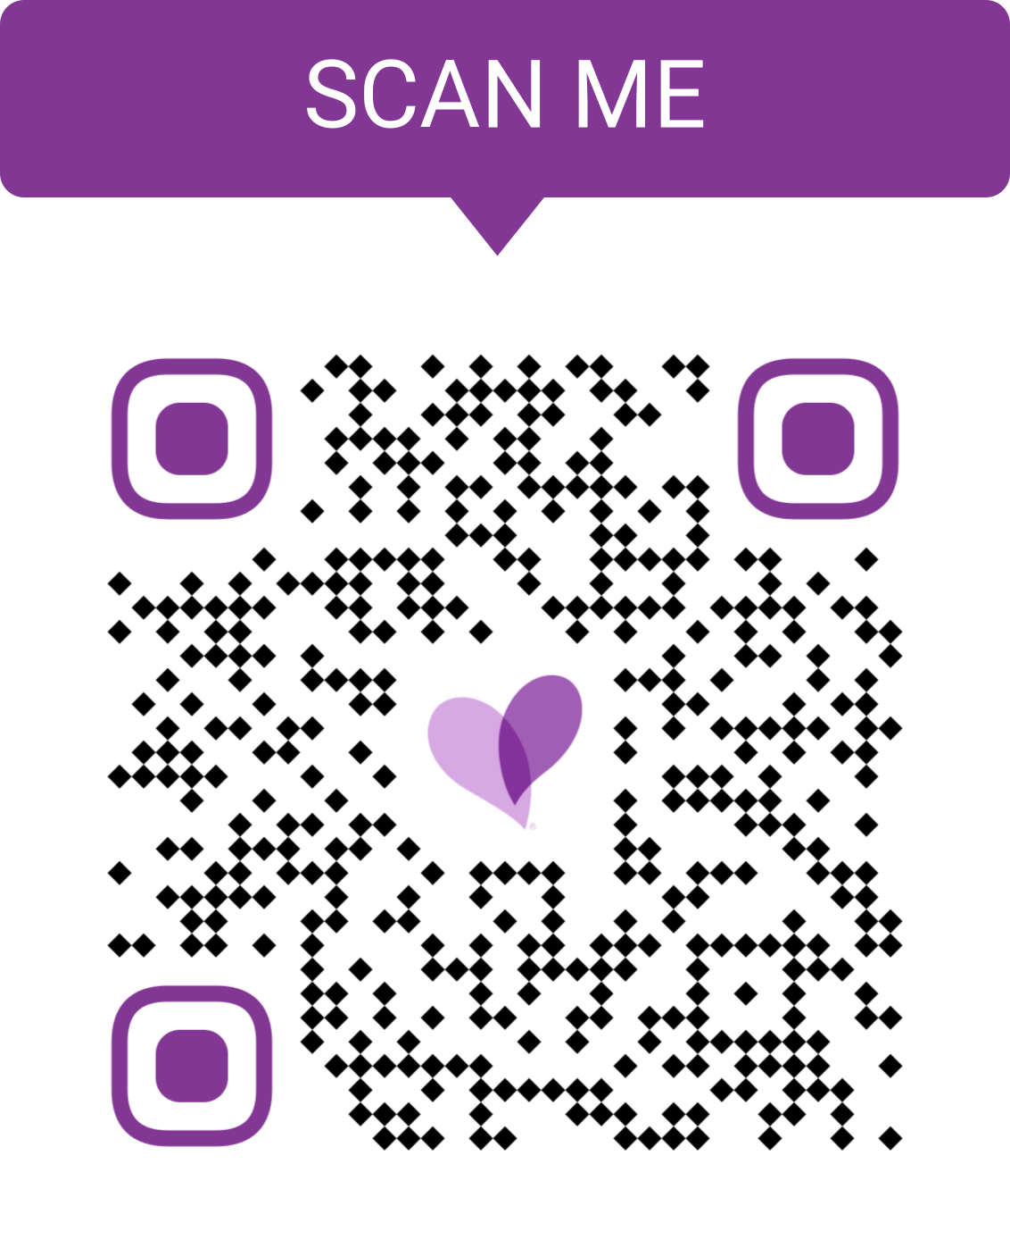
caresource.com

Solomon Parker is a visionary leader in the field of healthcare, serving as the Director of Intellectual and Developmental Disabilities (IDD) Program Strategy at CareSource, a nationally recognized nonprofit health plan with a mission to improve the health and well-being its members and communities. With a career spanning nearly two decades in Kentucky Medicaid waiver programs, Solomon possesses a wealth of experience and expertise in the realm of healthcare.

In his current role at CareSource, he champions transformative strategies and fosters innovative solutions tailored to the unique needs of individuals with I/DD. His unwavering commitment extends into critical areas such as community integrated employment and propelling a culture of diversity within the workplace.

Aarti Sahgal is the Founder & CEO of Synergies Work, the largest startup hub that empowers people with disabilities through entrepreneurship. As a mother of a young adult with Down syndrome and with over 18 years of experience in building inclusive communities and workforce strategies for individuals with disabilities, she is dedicated to challenging low expectations, redefining the disability narrative, and bridging the disability wealth gap. She is a board member at GA State Rehabilitation Council, recognized as a ‘Woman Making an Impact’, and a ‘Equity Champion’ award finalist by Startup Atlanta in 2023. With 14 years in marketing and a Master’s degree in business management, Aarti is a catalyst for change.

1.4 HOW TO BUILD A SUCCESSFUL YOUTH PROGRAM

- Track: Youth, Young Adults, and the Movement
- Location: Independence FGHI



In this workshop you will learn how to build a strong youth program that focuses on youth leadership, employment, college preparation and transitioning to living independently. Center for Independence and Central Washington Disability Resources will share their expertise and recommendations for building a youth program from scratch. CFI has had their youth program since 2009, and CFI and CWDR have collaborated with putting on a 5-day summer workshop that focuses on college preparation, job readiness and living independently. We will discuss building relationships with community partners, program retention, and outreach; all with an anti-racism lens.

Mayra Colazo is the Executive Director at Central Washington Disability Resources (CWDR). She has worked with individuals with disabilities for over nine years and is passionate about advocating for equality for all. She lives in a small rural town called Ellensburg in the Center of Washington State. CWDR covers a five-county area in Central Washington majority rural. She sees the struggles that individuals with disabilities experience in small rural towns, from lack of resources to lack of education. Mayra has been super active as part of committees that focus on advocacy for individuals with disabilities. On these committees, Mayra emphasizes the importance of policies and working to advance accessibility, education, access, and advocacy. #NothingAboutUsWithoutUs

Leah Velasco is the Executive Director of the Center for Independence (CFI). She has been serving the disability community for over 15 years. She has a Master’s degree in Social Work and is passionate about working with youth and young adults. Leah is a Washington state native and has three young children. Her personal experience with disabilities is what led to her passion for advocating for CILs. CFI serves 8 counties of Western Washington, with two office locations. The Board consists of over 50% of BIPOC individuals and CFI is committed to viewing its work through a DEIA lens.

1.5 INCORPORATING THE STATE PLAN INTO YOUR ORGANIZATION’S PLANS

- Track: Intergenerational Leadership
- Location: Lafayette / Farragut

Did you know that the State Plan for Independent Living (SPIL) is a comprehensive and strategic plan created specifically for the Independent Living network within a state? The SPIL outlines important priorities such as funding, outreach, and expansion for the IL network. It plays a crucial role in enabling the IL network to provide necessary services and support to individuals with disabilities.

If you are working at a CIL, have you incorporated the SPIL into your annual work plans as required by ACL? By doing so, you can ensure that your organization's work aligns with the priorities outlined in the SPIL. Similarly, if you are a member of your state's SILC, are you utilizing the SPIL to plan activities and focus efforts? In this session, we will guide you on how to easily incorporate the SPIL in your organization's work plans, outreach efforts, and resource development activities. By doing so, you can ensure that your efforts are aligned with the priorities of the IL network in your state, and you can better serve the people with disabilities in your community.

Mellie Adu (she/they), has worked for CILs in three states, currently serves as Chief Executive of Strategy and Innovation for the Arizona SILC, and has also served as a SILC member. Mellie recalls feeling hesitant about shifting from CIL to SILC work just over a decade ago, but after realizing the inherent potential SILCs have for strategic systems change, became passionate about maximizing opportunities to mitigate barriers. As a longtime facilitator of both strategic and action planning for individuals and organizations, Mellie is favorably regarded for pioneering projects, programming, and practices that promote sustainable progress.

Paula McElwee is the Director for Technical Assistance for the IL-NET National Training and Technical Assistance Center for Independent Living at ILRU. In addition to providing individualized technical assistance, Paula moderates training calls monthly for CIL staff and SILC staff and board members. She previously served on the board of Resources for Independence of the Central Valley and served as interim executive director for four CILs in California, assisting the boards to transition to their next executive director. Paula has provided training, facilitation and consultation with state associations, SILCs, and numerous Centers throughout the country.

Concurrent Workshops 2

2
Wednesday, July 24; 9:00 a.m. – 10:15 a.m.

2.1 RECOMMITMENT TO IL VALUES

- Track: Independent Living Across the Globe
- Location: Independence A

Panelists discuss the current state and future of the IL movement, and its emphases on community integration and self-leadership. In this session we call on the boards and executives of Centers for Independent Living (CILs) and Statewide Independent Living Councils (SILCs) to join us in recommitting to the aims of the IL movement so they align with the current needs and aspirations of our disabled communities.

Misty Dion, who proudly identifies as having a disability, is the CEO of the Roads to Freedom Center for Independent Living (RTFCIL) of North Central PA with over 20 years of experience advancing disability rights and justice on the local, state and national levels. Under Misty’s leadership, RTFCIL has become nationally recognized for its relentless opposition to guardianship, successful transition services and most recently, as the first CIL to provide emergency relocation services reimbursed through FEMA. She is a founding member of the national coalition Liberators for Justice and actively participates on NCIL Subcommittees. Misty is also a member of National ADAPT, having founded the North Central ADAPT chapter. She graduated Summa Cum Laude from Pennsylvania College of Technology with her Bachelor’s degree in Applied Science / Human Services.

Dominique Dunford is the Executive Director of the ENDependence Center of Northern Virginia (ECNV), in Arlington, VA. Dominique has doubled her CIL’s operating budget and realized a 60% increase in staffing. ECNV boasts a diverse and inclusive workforce that is over 80% disabled, linguistically rich in over six languages, Queer+-identifying, and spans from baby boomers to Generation Z. Dominique’s tenure is marked by a significant emphasis on transformation, focusing on integrating a racial equity and disability justice perspective into all facets of ECNV. Currently, she is spearheading a year-long strategic planning process, embedding these core principles deeply into the organization’s future trajectory.

Thomas Earl is CEO of Liberty Resources, Inc., a Center for Independent Living in Philadelphia. A Pennsylvania licensed attorney, he has been involved in the legal rights of people with disabilities since 1992 and worked previously with the Disabilities Law Project (now Disability Rights Pennsylvania) as an attorney representing people with disabilities in federal discrimination cases, and subsequently the ADA Project Manager, coordinating the enforcement of disability rights under the Americans with Disabilities Act across Pennsylvania.

Karen Tamley has been the President and CEO of Access Living in Chicago since 2020, succeeding founding CEO Marca Bristo. A lifelong disability rights advocate, Karen served eight years on the United States Access Board, is currently on the Obama Foundation Inclusion Council and the Illinois Commission on Hate Crimes and Discrimination. She previously served as Commissioner of the Mayor’s Office for People with Disabilities where she advanced disability inclusion in transportation, city infrastructure, technology, emergency planning, education, and employment. Karen, her husband, Kevin, and their teenage daughter are all disabled and actively involved in local and national disability advocacy.

Kimberly Tissot is President and CEO of Able SC where she guides staff in applying the philosophy of independent living to real situations. Kimberly believes in the value of individualized and community-based empowerment. In 2017, she led the efforts in passing South Carolina’s “Persons with Disabilities Right to Parent Act” and, in 2018 and 2022, ending subminimum wage in South Carolina. She holds a Bachelor of Science Degree in human development from Boston University, Wheelock College of Education, and a Master of Social Work from the University of South Carolina.

2.2 CULTIVATING INTERNATIONAL COLLABORATION AMONG IL CENTERS AROUND THE WORLD

- Track: Independent Living Across the Globe
- Location: Independence BC

Centers for Independent Living have the power to transform society. Countries in Asia and Latin America that Japan has supported, Centers for Independent Living have sprung up to empower people with disabilities and providing support for independent living, as well as advocating to develop necessary legal systems. IL centers bring people with diverse disabilities to work on assistance systems, accessibility, and anti-discrimination law. IL changed society and enabling us to live independently in the community rather than in institutions. It is our mission to extend what we have gained through IL to people with disabilities in developing countries around the world.

Shigeto Itani was born in 1978. He had a car accident at the age of 22 (2001) and became disabled. He was a university student at that time. He stayed in the hospital a long time and also in his parents’ house. He started living independently when he was 29 years old. He established CIL-HOSHIZORA (Starry Sky) in 2009 and has worked in the independent living movement since then. As for international work, he has traveled Jordan and Columbia to disseminate IL movements through JICA projects. Currently, he is serving as Vice-Chair of Japan Council on Independent Living (JIL), as Chair of the Peer-Counseling Committee at JIL, and as a board member of DPI-JAPAN.

Satoshi Sato lived in an institution after he acquired a disability at the age of 9. He got involved with the IL Movement when he met a person with a significant disability living independently. In 2003, he began assisting CILs in developing countries such as Pakistan, Nepal, Cambodia, Taiwan, Mongolia, Costa Rica, and Bolivia. Satoshi now serves at DPI-JAPAN as the Secretary General. His work involves policy negotiations, human rights protection, and accessibility.

2.3 ARTIFICIAL INTELLIGENCE AND WHY YOU SHOULD CARE: A CONVERSATION ABOUT EQUITABLE AI

- Track: Technology & Innovation
- Location: Independence DE

The meteoric evolution of technology and Artificial Intelligence (AI) brings both opportunities and challenges for people with disabilities. Join us for an interactive conversation about this new frontier: how this technology is being used, and how it can impact your finances, employment, and inclusion. We want to hear your experiences and concerns, and will share resources from LEAD Center and the Partnership on Employment & Accessible Technology’s and their AI Disability & Inclusion Toolkit.

Nancy Boutot has nearly 30 years’ experience in local, state, and national employment programs, focusing on community integration, employment policy, career pathways, and asset development. She brings subject matter expertise in Discovery and Customized Employment, financial empowerment, disability benefits management, work supports, and cross-systems collaboration. She is an experienced presenter and subject matter expert on employment and financial empowerment for individuals with disabilities.

Elizabeth Layman has subject matter expertise at the intersection of health equity, financial empowerment, and equitable technology. She has developed curricula for FDIC’s Money Smart and CFPB’s Your Money, Your Goals; managed user experience research for tech giants; and collaborated with diversity, equity and inclusion powerhouses like the NAACP and Unidos US. Most recently, Elizabeth led a national study on the impact of autonomous vehicles on employment and entrepreneurial opportunities for people with disabilities.

Sarah Loizeaux is a subject matter expert on creating inclusive career pathways to leverage resources across systems that promote employment for people with disabilities. She serves as a Training and Technical Assistance Manager for National Disability Institute. Sarah has developed innovative practices that increased programmatic access and workforce performance outcomes. Her expertise includes identifying Diversity, Equity, Accessibility, and Inclusion (DEAI) promising practices, emphasizing universal design principles.

2.4 EMPOWERING YOU(TH) IN THE JOURNEY OF AUTHENTIC RELATIONSHIPS

- Track: Youth, Young Adults, and the Movement
- Location: Independence FGHI

Transition Discoveries is a non-profit that stands on the principle that youth themselves should be the drivers of their own futures – both in post-secondary education, in their everyday lives, in the community, and in system-change settings. We believe that the foundation of all transition is meaningful relationships, making authentic connections an essential part of youth empowerment. Are you a young person just hoping you’ll bump into someone who truly gets it one day? Someone who asks the right questions, understands your life experiences, and helps you get to where you want to go? Or are you an adult ally wondering what questions you should be asking youth? Join us in this interactive session led by a 22-year-old self-advocate and the Transition Discoveries team with the purpose of asking the RIGHT questions utilizing our Discovery Cards, conversation cards made to build community in the midst of life transitions.

Erin Black, a current team member of Transition Discoveries, is a young and vibrant disability advocate that feels passionate on the importance of youth empowerment as a young woman living with a disability herself. Erin is a recent graduate from the University of Toledo with a degree in Disability Studies and Public Relations. Born with a rare neuromuscular condition, Erin made it her life mission to travel the world telling her story with the hopes that other youth living with disabilities will quickly understand the importance of their voice in rooms where decisions are being made. Erin has found a passion for public speaking and visual creation relating to marketing / social media, which has led to her involvement in Transition Discoveries. You can connect with Erin and read more on her story at erinblack.net.

Joan Kester is the founder of Transition Discoveries. Being an advocate for systems change, Joan describes herself as the following: Thought Leader, Network Weaver, Community Builder, Co-Creator, Systems Change Agent, Innovator, Entrepreneur, Youthful Spirit, Advocate, Mentor.

Erin Weierbach has been working alongside youth and families for 20 years. Living with a disability herself, she is passionate about educating people around self advocacy and driving systems that support them. She has co-designed resources and programs supporting young people, including being an adult ally for the Pennsylvania Youth Leadership Network and the Transition Discoveries Initiative through The George Washington University. In addition, she is currently the Community Programs Specialist for the Charcot Marie Tooth Association and co-owner of Get Smok’d BBQ with her husband.

2.5 BUILDING COMMUNITY THROUGH PRIDE

- Track: Intergenerational Leadership
- Location: Lafayette / Farragut

Building Community through PRIDE’ workshop speaks to the need to celebrate Disability Pride in the work we do. Self-advocacy begins with pride. We have found that Disability Pride is key to community building and better advocacy engagement. Join us for a conversation on how Disability Pride celebrations can build capacity in your work. Let’s talk through the ways you can celebrate with funding vs little to no budget.

Vicki Landers is a proud, queer femme that lives with both visible and unseen disabilities. She is grounded by her partner, her familiars, and her son Kyle. She enjoys hunting for vintage Halloween items, early 1900’s colored glass, anything Tim Burton, and eating tacos. Vicki’s background is in retail management, training, and customer service, as well as being an artist. She is the Founder and Director of Disability Pride Pennsylvania. She found her space in the disability community by providing FUN. She says, “We as a community are inherently fighting for our rights to live independently and to be heard by the medical professionals, as well as our own bodies. We need a space to enjoy, have fun, and celebrate the victories.” DPP programming includes disability pride events to bring communities together in a fun social way. DPP believes that bringing people together socially creates stronger communities, and stronger communities have better conversations.

Concurrent Workshops 3
3
Wednesday, July 24; 10:30 a.m. – 11:45 a.m.

3.1 DME, LTCFS AND HEALTHCARE: WHAT PRIVATE EQUITY HAS TO DO WITH IT (WHAT IT MEANS AND HOW TO COMBAT IT)

- Track: Back to Our Future
- Location: Independence A

In recent years, for-profit private equity firms have bought healthcare, disability and Durable Medical Equipment (DME) services and settings. Facing limited regulatory oversight, these firms stealthily acquire disability, home and healthcare facilities / services and implement their business model emphasizing immediate returns on investment. Here, private equity firms profit by cutting costs, exploiting government programs, reducing service quality, quality of care and ultimately endangering residents.

Farrah Garland describes themselves as “good, necessary trouble,” to borrow a phrase from civil rights legend Congressman John Lewis. They are a disability and queer rights activist and advocate based in Stonington Connecticut (CT). They love their work, which ranges wildly, but all circles around the core concepts of human rights, diversity, equity, and accessibility.

They started off by “yelling at stairs,” a term they still use today to describe their work. Which is to say, advocating and doing education about inaccessibility in everyday locations. This led to consulting work and a seat on the CT SILC. Farrah has taken their fight for the rights of marginalized communities to the political sphere by bringing a disabled, queer, and nonbinary / trans perspective to the table.

Carol Tyson is the Government Affairs Liaison for the Disability Rights Education and Defense Fund (DREDF), a national law and policy center, with offices in Berkeley, California and Washington, D.C. Tyson provides an advocate voice in the District, and works in coalition with disability and civil rights partners and industry stakeholders, focusing on: transportation equity; healthcare; supports and services needed to remain in the community; education; and civil rights. Prior to joining DREDF, Tyson served as the Director, Disability Policy for United Spinal Association, and as a researcher in the labor movement supporting workers in the US and Australia.

Colin Killick (he/him/his) is the Executive Director of Disability Policy Consortium (DPC), a statewide civil rights advocacy and research organization run by and for people with disabilities. He co-founded the Housing Advocacy Leadership Team (HALT), which since 2014 has successfully advocated to more than quadruple Massachusetts’ investment in affordable housing for people with disabilities, and led DPC’s successful efforts to overturn and replace Massachusetts’ discriminatory COVID-19 Crisis Standards of Care in 2020. He has motor dysgraphia, executive function disorder, and major depression, and credits the accommodations he received thanks to prior generations of disability rights advocates for being able to do this work.

Tom Olin is most known for his photojournalism and involvement in the disability rights movements and campaigns for disability justice for over the last 40 years. That history includes 10 Centers for Independent Living throughout the country, NCIL, APRIL, ADAPT, Not Dead Yet, MindFreedom, SABE, and Mouth Magazine Tom has done two tours with the “Road to Freedom” bus; he is CEO of the Disability Rights Center; and is a founding member of DisDATA, SILVER and Liberators 4 Justice. He recently moved to Tucson, AZ where he joined the board of directors of the Center for Independent Living, DIRECT.

3.2 ENGAGING THE YOUTH TO UNLEASH THE POWER OF STORYTELLING IN SELF-ADVOCACY

- Track: Youth, Young Adults, and the Movement
- Independence BC

Stories connect people and help them to know they are not alone. This workshop will expose the youth in transition to hear the untold stories of some of our activists / advocates who are fighting disability rights and dismantling ableism across the globe. The youth also need to know that strategic story telling is essential in self-advocacy as well as systems advocacy. There is the urgency to empower them with the tools and encourage them to use them to support advocacy effectively.

Sefakor Komabu-Pomeyie (Ph.D.) works with Vermont Center for Independent Living as the Independent Living Coordinator in charge of the Youth Transition Programs. She works with all students with IEP / 504 plans across the State of Vermont between the ages of 14 to 26 to build their self-advocacy skills and strategies. She also teaches the Global Disability Studies course and Race and Racism course as adjunct at the University of Vermont. As one of the experts of Universal Design for Learning (UDL), she won the prestigious Prelock 2022 award for her excellent asynchronous online course at the University of Vermont. At Saint Michael’s College, she teaches Disability Justice and Ethical Leadership and Disability Policies, a course designed for Principals and other leaders.

3.3 BUILDING AN ACTION-ORIENTED ADVOCACY NETWORK

- Track: Technology & Innovation
- Location: Independence DE

Innovating the future of Internet advocacy through the use of online tools: Join California Foundation for Independent Living Centers and the California State Independent Living Council for a presentation on the future of policy advocacy and systems change organizing.

Dan Okenfuss is the California Foundation for Independent Living Centers’ Public Policy Manager. He facilitates the CFILC Public Policy Committee, led by CFILC members. Previously, Dan worked in Washington, DC and California as a legislative staffer.

Russell Rawlings is the California Foundation for Independent Living Centers’ Community Organizing Manager. He is responsible for managing the DOnetwork (Disability Organizing Network), a California statewide systems change network.

3.4 CREATING YOUR OWN PEER NETWORK

- Track: Intergenerational Leadership
- Location: Independence FGHI

One of the key principles of the IL philosophy is peer support for consumers. This means that people with disabilities provide support and guidance to each other based on their shared experiences. However, as employees with disabilities working in cross-disability, disability-led organizations, we also need to ensure that we have adequate peer support for ourselves. We have a unique perspective and face specific challenges in the workplace that can be difficult to navigate without support. That’s why it’s important to establish a strong support system for ourselves.

This session will provide you with practical advice, tools, examples, and resources to help you do just that. You’ll learn how to connect with other like-minded people and establish a support network that can help you navigate the challenges of the workplace. You’ll also learn how to be a good support person for others and how to create a supportive environment within your organization. Remember, peer support is not just for consumers; it’s equally important for employees with disabilities. By connecting with others and enhancing your own peer network, you can build a stronger and more supportive IL network for everyone. Don’t miss out on this opportunity to learn and grow!

Sandra Breitengross Bitter (she/her), a Hispanic, neurodivergent individual with lived experience in mental health, originally hails from a small desert town in California but now calls Texas home. After receiving a Bachelor of Science in Political Science from California Baptist University, Sandra spent the first part of her career working in public policy for the U.S. House of Representatives. In 2012, she joined the Texas SILC staff and most recently held the position of Executive Director. In 2022, Sandra became the Director of Training for the ILRU IL-NET T&TA Center for Independent Living.

Jeremy Morris is the Executive Director of the Ohio SILC. Before joining the SILC in 2017, Jeremy had spent almost 10 years working in Independent Living, previously serving as the Executive Director of the Access Center in Dayton, OH and Finance Coordinator at the Western Reserve ILC in Warren, Ohio. His background in CILs includes direct services, advocacy and community partnerships, and operations management. He holds a Bachelor of Science in Business Administration.

Tyler Morris is the Executive Director at CIL Jacksonville in Jacksonville, FL. He has worked in the Independent Living field since 2007. Morris will soon complete his final term as the Network of Centers Representative, where he led initiatives like the statewide compensation analysis of CILs and a CIL-to-CIL support network called “Core Connections.” He is an alumnus of the University of North Florida, where he gained his Bachelor's Degree in Education - Deaf Studies and a Master’s in Business Administration. Morris is a proud member of the disability and LGBT+ communities and advocates for going further together.

Kimberly Tissot is the President and CEO of Able SC in South Carolina and has over 20 years of experience advancing disability rights and inclusion. Kimberly is recognized nationally for mentoring other CILs in applying the IL philosophy to real-world circumstances. In South Carolina, Kimberly led legislative campaigns to successfully pass the “Persons with Disabilities Right to Parent Act” in 2017 and to end subminimum wage in 2022. A proud person with disabilities, Kimberly exemplifies peer leadership and advocacy.

3.5 GLOBAL DISABILITY-INCLUSIVE DISASTER RISK REDUCTION STRATEGIES

- Track: Independent Living Across the Globe
- Location: Lafayette / Farragut

People with disabilities are 2-4 times more likely than others to be injured or die in disasters, primarily due to inadequate community-wide planning and access to emergency and disaster assistance. Through sharing the collaboration efforts made by organizations like WID through the Global Alliance for Disaster Resource Acceleration (GADRA) this session will include stories of innovative collaboration by disability-led organizations before, during, and after disasters.

Marcie Roth, a distinguished leader, has been a trailblazer in disability advocacy for almost 50 years, including working for a CIL and chairing two SILCs. In response to the 9/11 attacks, while serving as NCIL’s Director of Advocacy and Policy, Marcie shifted her advocacy towards enhancing emergency preparedness and disaster outcomes for people with disabilities. Appointed by President Obama to FEMA, she served as Senior Advisor, leading the Office of Disability Integration and Coordination from 2009 to 2017. Marcie advises governments, corporations, health systems, and the United Nations. In 2020, she launched the Global Alliance for Disaster Resource Acceleration, connecting funders with disability-led organizations for swift humanitarian relief.

Concurrent Workshops 4
4
Thursday, July 25; 9:00 – 10:15 a.m.

4.1 UNDERSTANDING OUR PAST AS WE MOVE FORWARD TOGETHER

- Track: Back to Our Future
- Location: Independence A

Fusion organizing brings together diverse groups working on common social justice goals. In New York, Caring Majority, Poor Peoples Campaign and Centers for Independent Living have come together fighting interwoven issues of poverty and oppression.

We have listened and learned from different perspectives. We have shared our Disability Rights History, heard from others fighting similar battles. Learning our strength comes from telling our stories, coming together, becoming the Critical Mass. We take back our power when we rebuild together. The Social Justice Movement takes all of us working together, organizing together to be the force for change that moves us forward, together.

Julie Farrar holds a B.S.in Human Services, Non-Profit Administration from Metropolitan State University and has worked in Long Term Care Health Policy for over fifteen years. Julie has been involved in the disability rights movement since she met Wade Blank and the Gang of Nineteen in Denver, when was she was 16 years old. She participated in the ADAPT Capitol Crawl in DC in 1990, using direct action tactics to persuade legislators to pass the Americans with Disabilities Act. Julie currently works on building a fusion Social Justice Movement that includes perspectives and leadership from the disability community.

Clifton Perez of Troy, New York has been working in the field of advocacy to enhance and defend the rights of people with disabilities since 1985. He holds a Master’s degree in social work from the University of Stony Brook NY, and currently serves as the Systems Advocate for the Independent Living Center of the Hudson Valley. He has served as NCIL’s Vice President and Region II Representative. He represented NCIL on the U.S Access Board’s Railroad & Vehicle Accessibility Advisory Committee (RVAAC). In 2016, he was appointed to the New York SILC and to represent NYSILC on the state Rehabilitation Council.

Julia Solow (she/her) has a passion for organizing that comes from a long legacy of organizing in her family, personal experiences of struggle, and amazing mentors along her journey. She has been involved in grassroots organizing work ever since social work professors in college introduced her to immigrant rights leaders fighting for the DREAM Act in 2010. For the past five years, Julia has been one of the lead state-wide organizers on the Fair Pay for Home Care campaign. Julia has a Master’s degree in Social Work from CUNY Hunter College.

4.2 A GENERAL OVERVIEW OF THE UNITED NATIONS CONVENTION ON THE RIGHTS OF PERSONS WITH DISABILITIES (CRPD)

- Track: Independent Living Across the Globe
- Location: Independence BC

The General Overview of the United Nations Convention on the Rights of Persons with Disabilities (CRPD) session will focus briefly on the history of the Convention, human rights in the Convention, States (countries’ obligations), implementation and monitoring, and the role of persons with disabilities and representative organizations. Attendees will also receive an update on the US Senate’s efforts to ratify the UN CRPD.

Isabel Hodge is a distinguished leader and advocate in the international disability rights movement. As Executive Director of the United States International Council on Disabilities (USICD), she manages a 31-year global networking and consulting hub with relationships with organizations of persons with disabilities in countries around the world. Isabel’s advocacy work involves striving for the US’ ratification of and promoting and assisting countries with their implementation of the United Nations Convention on the Rights of Persons with Disabilities (CRPD). Prior to joining USICD, Isabel was a Senior Analyst for the U.S. Department of Defense Office of Special Needs. She currently serves as the Secretary of Disabled Peoples International (DPI), as the Vice President of DPI North America and the Caribbean.

LeAnn Naillon has served on the NCIL International Subcommittee since 2018 and was recently appointed as Chair. She has had the honor of working in the inclusive sports, recreation, and leadership space for over 20 years. During that time, she worked at a Center for Independent Living where she worked with an international exchange between Mongolia, Japan, and the United States. LeAnn is an alumnus for Sports Diplomacy and Young Southeast Asian Leaders Initiative Professional Fellowship Program (YSEALI PFP) exchange programs sponsored by the U.S. Department of State’s Bureau of Educational and Cultural Affairs. Since 2014 this work has introduced her to individuals, communities, and organizations addressing disability issues in China, Laos, Vietnam, Azerbaijan, and Brunie Darussalam. She continues to consult on both programs that provide opportunities to elevated global minded leaders with integrity.

4.3 SUCCESSFUL TRANSITIONS: THE COLLABORATION OF FLORIDA CILS WITH SUNSHINE

- Track: Technology & Innovation
- Location: Independence DE

Building on the Peer Support and Nursing Home Transitions core services of CILs, Sunshine Health (Centene) developed a Value Based Payment program to assist Sunshine member consumers to transition from nursing facilities to the community. The session will review the processes, challenges and outcomes of this innovative collaboration leveraging assessments, assistive technology and peer supports tools to improve consumer outcomes, independence and quality of life. The alignment of the goals and objectives of a Medicaid managed care plan with the values and principles of Independent Living supported by meaningful financial incentives for participating CILs has resulted in successful multi-disciplinary model of community transition success that can be replicated in other states.

Jane Johnson is the Executive Director of the Florida Association of Centers for Independent Living. In this role, she works with state agencies and the Florida Legislature to advocate on behalf of Florida’s network of Centers for Independent Living, whose mission is to ensure Floridians with disabilities can live independently in their communities and pursue their educational, employment and personal goals. Jane earned a Bachelor of Arts Degree from Georgetown University and a Master’s degree in Public Administration from Norwich University.

Bridget Smith is a Director of Case Management with 20+ years of experience in the healthcare sector. Bridget is skilled in leading and increasing responsibility in staff development, promoting healthcare compliance, and program administration. Bridget is a dynamic and empowering leader who drives solutions while increasing efficiency and supporting employee development to provide outstanding customer service. Bridget is an expert in managing federal grants to improve health in underserved communities and is committed to providing exceptional management.

Joseph Medina has over 13 years of experience in the healthcare industry, and has focused efforts on serving the elderly and underrepresented populations of Florida. A graduate of both Florida State University and the University of North Florida, Joseph began a career in insurance, striving to ensure people were able to protect their most treasured asset, their family.

Transitioning into healthcare, Joseph aided seniors in Florida to secure affordable healthcare with flexible options and minimal cost. For the past 10 years, Joseph has helped lead the Long-Term Care program for Sunshine Health. Focused on compliance, regulatory reporting, and strategic initiatives, Joseph has spearheaded multiple projects designed to address homelessness, improve provider engagement, and increase member satisfaction while residing in the community.

4.4 RELATIONSHIPS – THE SECRET SAUCE TO YOUTH ENGAGEMENT

- Track: Youth, Young Adults, and the Movement
- Location: Independence FGHI

Relationships are the secret sauce to the good things in life, especially when it comes to young people! During this session, presenters will share some of the ways they collaborate with youth-serving organizations and systems as well as how they engage youth themselves. The audience will learn best practices for different communication styles and get tips on being authentic to build positive relationships. This session is great for anyone wanting to identify places to connect with youth and young adults, and gain confidence around finding common ground to create opportunities for young people to have a voice in systems that support them. After learning from examples how to create more successful outcomes for youth, audience members will be able to improve communication within existing relationships, identify new ways to engage young people, and bridge gaps with other organizations and providers.

Erin Black, a dynamic disability advocate and team member at Transition Discoveries, holds a degree in Disability Studies and Public Relations from the University of Toledo. As a recent graduate living with a rare neuromuscular condition, Erin is dedicated to empowering youth with disabilities. Passionate about public speaking and visual creation for marketing / social media, she shares her inspiring story worldwide. Connect with Erin and learn more at erinblack.net.

Erin Weierbach has been working alongside youth and families for 20 years. Living with a disability herself, she is passionate about educating people around self advocacy and driving systems that support them. She has co-designed resources and programs supporting young people, including being an adult ally for the Pennsylvania Youth Leadership Network and the Transition Discoveries Initiative through The George Washington University. In addition, she is currently the Community Programs Specialist for the Charcot Marie Tooth Association and co-owner of Get Smok’d BBQ with her husband.

4.5 LIVED EXPERIENCE LEADING THE WAY

Track: Intergenerational Leadership
Location: Lafayette / Farragut

More than a decade ago, UnitedHealthcare Community & State (UHCCS) started a National Advisory Board (NAB) to create a space for members, advocacy groups and other key stakeholders to provide input on the program design and delivery system that supports individuals with special healthcare needs. Join UHCCS NAB organizer Michelle Martin along with NAB members Theo Braddy, Jennifer Kucera and Edward Mitchell for a panel discussion on the work of the NAB, including self-direction and self-advocacy, and the value of participating on a National Advisory Board.

Theo W. Braddy graduated from Temple University with a Master’s degree in social work in 1988, after receiving his Bachelor’s degree in social work from Edinboro University. At the age of 15, he became a person with a disability due to a high school football accident that left him paralyzed from the neck down. For more than 40 years, Braddy has advocated on behalf of persons with disabilities. He was hired in 1988 as CEO of the Center for Independent Living of Central Pennsylvania. As CEO, he created a CIL that has become a strong and growing voice for persons with disabilities. Braddy has taught at Temple University and Millersville University as an adjunct professor. Braddy became the Executive Director of NCIL in 2023.

Jennifer Kucera is a disability thought leader, public speaker, master storyteller, consultant, educator and systems change advocate with 53 years of lived experience. Born with a form of Muscular Dystrophy called Spinal Muscular Atrophy, Jennifer has been a lifelong advocate. She currently serves as a member of UnitedHealthcare’s National Advisory Board, a member of Ohio’s Developmental Disability Council, Chair of the Ohio Olmstead Task Force’s Direct Care Workforce Crisis work group and spent many years as a math teacher.

Edward Mitchell was a victim of a hit-and-run bicycle accident in 2003, struck by a vehicle and thrown into a ditch, where he was found by his younger brother. As a result of the accident, Edward has quadriplegia with an incomplete spinal cord injury. He obtained his Master’s degree in business administration in 2011 from Union University. He works as the Interim Executive Director of the SILC of Tennessee while serving on numerous boards, including a three-year term on the Statewide Council on Developmental Disabilities.

Concurrent Workshops 5
5
Thursday, July 25; 10:30 – 11:45 a.m.

5.1 DISABILITY RIGHTS LAWSUIT SAYS ASSISTED SUICIDE LAWS VIOLATE THE ADA

- Track: Back to Our Future
- Location: Independence A

Assisted suicide laws set up a two-tiered system where some suicidal people receive suicide prevention while others receive suicide assistance, and the difference is their health and disability. This endangers older, ill and disabled people, especially from BIPOC, poor and other marginalized groups. Learn about the groundbreaking lawsuit challenging assisted suicide as unlawful discrimination under the ADA, Section 504 and the U.S. Constitution. All people with disabilities deserve equal healthcare and suicide prevention, not healthcare disparities and suicide assistance.

Anita Cameron has been Not Dead Yet’s Director of Minority Outreach since January 2017. She has met with national and state policy makers and written persuasively about opposition to a public policy of assisted suicide from the perspective of communities of color who experience disparities in access to healthcare. Previously, she worked at the American Association of People with Disabilities (AAPD) in Washington, D.C. to get out the disability vote, and as Systems Advocate for the Center for Disability Rights in Rochester, NY, from 2006-2010, addressing a broad range of disability rights issues. Anita currently serves on the National Disability Leadership Alliance’s Racism Taskforce. She holds a degree in Biology from University of Illinois at Chicago Circle and a degree in Computer Information Systems from Community College of Denver.

Ian McIntosh is Deputy Director of Disability Outreach at the Patients Rights Action Fund, an organization that organizes diverse coalitions in individual states to oppose assisted suicide bills. Ian has long personal experiences with the intersection of disability and healthcare and has advocated for and written on various topics, having been published in the International Journal of Disability, Community, & Rehabilitation. Ian’s professional experience in outreach is also informed by his leadership with labor union organization in his native Ontario, Canada. Ian handles the accessibility for and outreach to leaders in the disability rights movement and the disability community.

Vincenzo Piscopo is the President / CEO of United Spinal Association, an organization founded by paralyzed veterans and which represents people living with spinal cord injuries and disorders (SCI/D) in the United States. Piscopo, a wheelchair-user who was paralyzed from a herniated disk in 2010, is also the founder and board member of the Wheels of Happiness Foundation which helps people with motor disabilities in disadvantaged areas of the world. Piscopo resides with his wife and four children in Atlanta.

5.2 SUPPORTIVE DECISION MAKING: AN ALTERNATIVE TO GUARDIANSHIP

- Track: Youth, Young Adults, and the Movement
- Location: Independence BC

This session will provide an overview of Supported Decision Making and the process to mobilize self advocates, families and providers to use supported decision making.

Molly Cole is the Executive Director of the Connecticut SILC. She has over 40 years of experience in the field of developmental disabilities and non-profit management. She comes to this position with an array of leadership experience, including serving as the Associate Director of the University of Connecticut Center for Excellence in Developmental Disabilities and the Director of the Connecticut Council on Developmental Disabilities. She is the past president of the National Association of Councils on Developmental Disabilities, a founding member of Family Voices, a national grassroots organization, and past president of the National Family Voices Board of Directors.

Gretchen Knauff is the Director of the Department of Services for Persons with Disabilities for New Haven, Connecticut. For the past 35 years, she has advocated for the rights of persons with disabilities while holding various positions at the Connecticut Office of Protection and Advocacy for Persons with Disabilities (P&A), most recently as Assistant Director. She also worked to establish Disability Rights Connecticut and became its first Executive Director. Gretchen is currently a Board Member of the ADA Coalition of Connecticut and the Connecticut SILC. Gretchen is passionate about the civil and human rights of people with disabilities and works toward creating a community where everyone truly belongs.

5.3 ADVANCING INDEPENDENT LIVING AS A NETWORK: CLARIFYING THE ROLES OF CILS, SILCS, AND DSES

- Track: Back to Our Future
- Location: Independence DE

Effectively growing the IL movement requires a mutual understanding of IL network members’ respective roles and awareness of the statutory and federal regulations that define the responsibilities for each member. During this session staff from ACL’s Office of Independent Living Programs (OILP) will review requirements for Centers for Independent Living (CILs), the Statewide Independent Living Councils (SILCs), and the Designated State Entities (DSEs) and their complementary roles, which require coordination for a strong IL network. The OILP team will also share how they monitor these requirements and what your network can do to make sure members are meeting them.

Ed Ahern is a Program Officer within the Office of Independent Living Programs at the Administration for Community Living (ACL). Prior to joining the ACL team in 2022, Ed spent 8 years as a Disability Integration Specialist with the Federal Emergency Management Agency (FEMA). Ed became involved with Independent Living more than 30 years ago when he began using a manual wheelchair after becoming disabled following a car accident.

Erica McFadden is the Director of the Office of Independent Living Programs at the Administration for Community Living (ACL). While she has been with ACL for a little more than 2 years, she has more than 25 years of experience in disability policy. She has worked in leadership positions at a university think tank, a state DD council, and a Center for Independent Living. She holds a Ph.D. in Public Administration & Policy from Arizona State University, an MSW from Virginia Commonwealth University (VCU), and dual Bachelor’s degrees from the University of Texas at Austin. She also has cerebral palsy.

5.4 THE TRUTH ABOUT NONSPEAKERS: LET US SPELL IT OUT FOR YOU

- Track: Youth, Young Adults, and the Movement
- Location: Independence FGHI

“Nothing About Us Without Us!”, the cry at the start of the Independent Living Movement, has no power if you have no voice. 2.4 million autistics and other nonspeaking people in the US cannot use our mouths to communicate today. We have been presumed to lack the ability to understand, reason and learn. This myth deprives us of agency, autonomy, and opportunity. We have motor problems, not cognitive. Learn how more nonspeakers can be freed from silence and join us in advocating for ourselves.

This workshop will be presented by members of the Spellers & Allies Advocacy Network.

5.5 PEOPLE POWER! WORKING TOWARDS TRULY INCLUSIVE DISABILITY COMMUNITY RESEARCH PARTNERSHIPS

- Track: Intergenerational Leadership
- Location: Lafayette / Farragut

The purpose of the workshop will be to discuss why it is mutually beneficial and important for disability community members and researchers to collaborate on research. The workshop will also discuss challenges of engaging with research from the perspective of disability community members. The presenters will use the Community Living Equity Center’s (CLEC) study as a model where disabled people of color are involved in every step of the research.

Tyree Brown is a Christian visual artist. In 2015 she became quadriplegic during a car accident. She received her Associate degree in Fine Art at the Corcoran School of George Washington University and a Media Production certificate at the Prince George’s Community College. She works as a video editor for a nonprofit and as a Lived Experience researcher for the Lurie Institute for Disability Policy at Brandeis University.

Kim The (she/her) is a senior research associate at the Lurie Institute for Disability Policy. She holds a Ph.D. in Disability Studies with a concentration in gender and women’s studies. Her research centers around building more intersectional disability activist groups— particularly in regards to women of color with disabilities. As a qualitative researcher, Kim assists with data analysis and manuscript writing across the various Lurie centers. Kim is passionate about working with people with disabilities throughout the research process.

Mary-Kate Wells serves as Program Director at NCIL. She has 10 years of experience in the disability and Independent Living field. Prior to her current role, Mary-Kate worked at her local CIL in Boston Massachusetts, managing a growing youth program and home modification program. She believes in creating equitable and sustainable programs that emphasize collaboration and accountability. She holds a Master’s degree in Rehabilitation Counseling and a Bachelor’s degree in psychology from Salve Regina University. She is a Certified Rehabilitation Counselor (CRC) with a commitment to advancing the rights of people with disabilities. Mary-Kate is a proud member of the disability community bringing lived experience with chronic illness, mental health, and learning disabilities.

Speakers

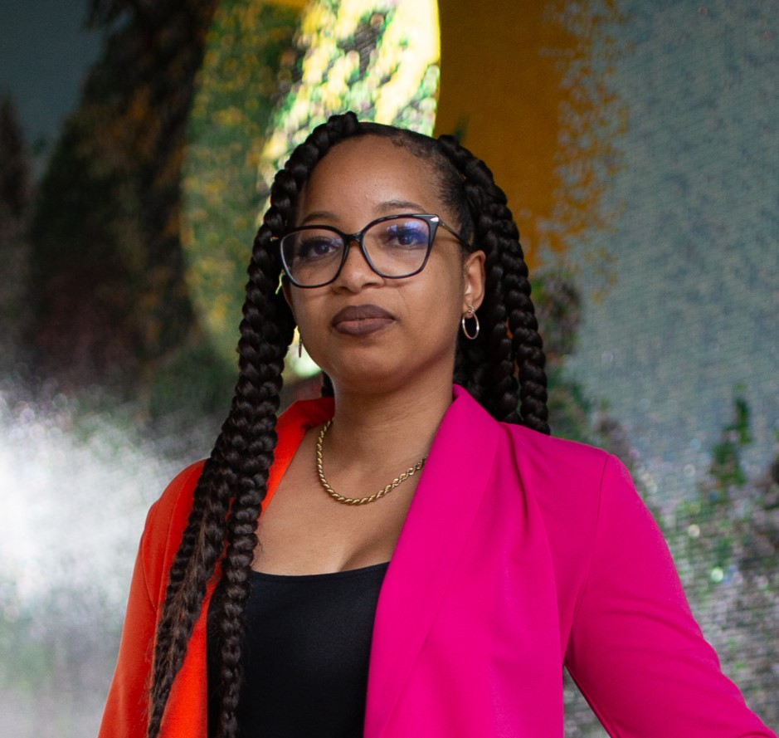

Keri Gray (Opening Plenary)

Keri Gray is a cancer survivor, entrepreneur, speaker, and facilitator. She is the CEO of the Keri Gray Consulting Group, where they strive to create professional communities of understanding through disability and racial justice education. She is also founder of the National Alliance of Melanin Disabled Advocates (the NAMED Advocates), which creates spaces for disabled leaders of color and BIPOC allies to gather, learn, connect, and grow around racial and disability justice.

Keri’s work has been featured in Teen Vogue, the New York Times, People Magazine, Time Magazine, PBS NewsHour, Madamenoire, and the Diet Coke campaign #Unlabeled.

Tony Coelho (Opening Plenary)

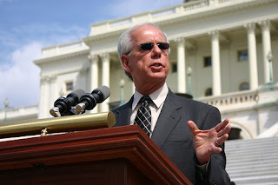

Tony Coelho was elected to Congress in 1978 and served for six terms until 1989. He served on the Agriculture, Interior, Veterans Affairs, and Administration Committees during his tenure, specializing in disabled rights.

Coelho was the original author of the Americans with Disabilities Act, signed into law by President George H.W. Bush. President Bill Clinton appointed Coelho to serve as Chairman of the President’s Committee on Employment of People with Disabilities, a position he held from 1994 to 2001. He also served as Vice Chair of the National Task Force on Employment of Adults with Disabilities.

In March 2009, Coelho was named as Chairperson for the Partnership to Improve Patient Care (PIPC). In this capacity, Coelho works to amplify the voice of the partnership’s diverse members, including people with disabilities, racial and ethnic communities and the elderly, among others.

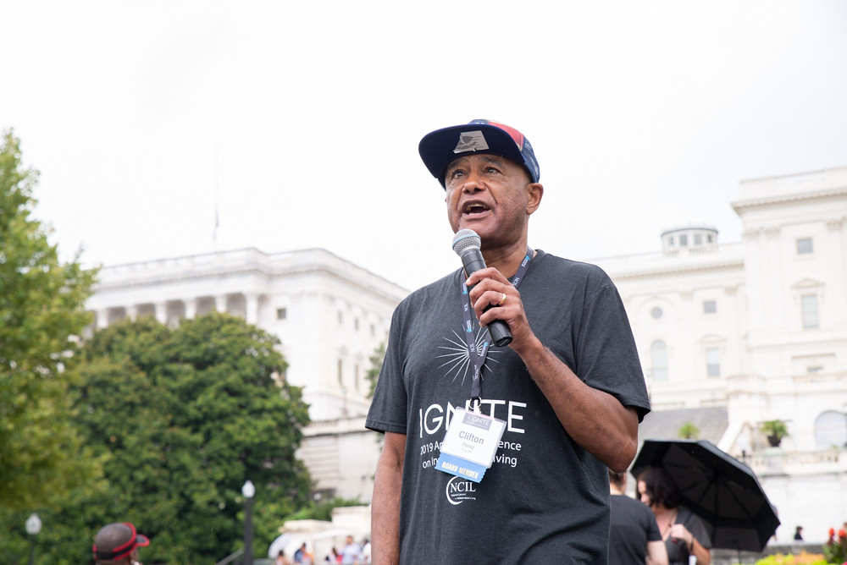

Cliff Perez (Opening Plenary)

Clifton Perez of Troy, New York has been working in the field of advocacy to enhance and defend the rights of people with disabilities since 1985. He holds a Master’s degree in social work from the University of Stony Brook NY.

Cliff currently serves as the Systems Advocate for the Independent Living Center of the Hudson Valley. He has served as NCIL’s Vice President and Region II Representative. He represented NCIL on the U.S Access Board’s Railroad & Vehicle Accessibility Advisory Committee (RVAAC). In 2016, he was appointed to the New York SILC and to represent NYSILC on the state Rehabilitation Council.

Jim Ward (Opening Plenary)

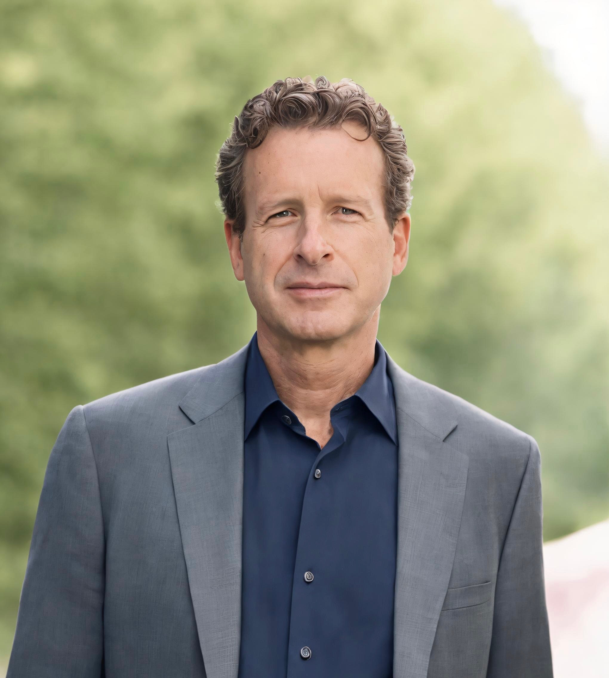

Jim Ward, MSW is the founder and executive director of ADA Watch and the Coalition for Disability Rights & Justice (CDRJ), an alliance of disability, civil rights and social justice organizations working to amplify the many voices of the U.S. disability rights movement. He is a person with a neurodevelopmental disability, a former elected official and a father. He produced the Road To Freedom bus tour and lived on the road for 18 months mobilizing grassroots support for passage of the ADA Amendments Act of 2008.

A former elected official and state party executive, Jim is a senior communications and government relations professional with extensive experience in building powerful coalitions of individuals and organizations to promote causes and effect real change. Ward has considerable experience in public policy analysis and advocacy, as well as drafting legislation and lobbying the U.S. Congress, Executive Branch, Federal agencies, and state and local governments. He is a veteran grassroots organizer committed to leadership development, organization building and community empowerment.

Sherman Gillums, Jr. (Awards Luncheon)

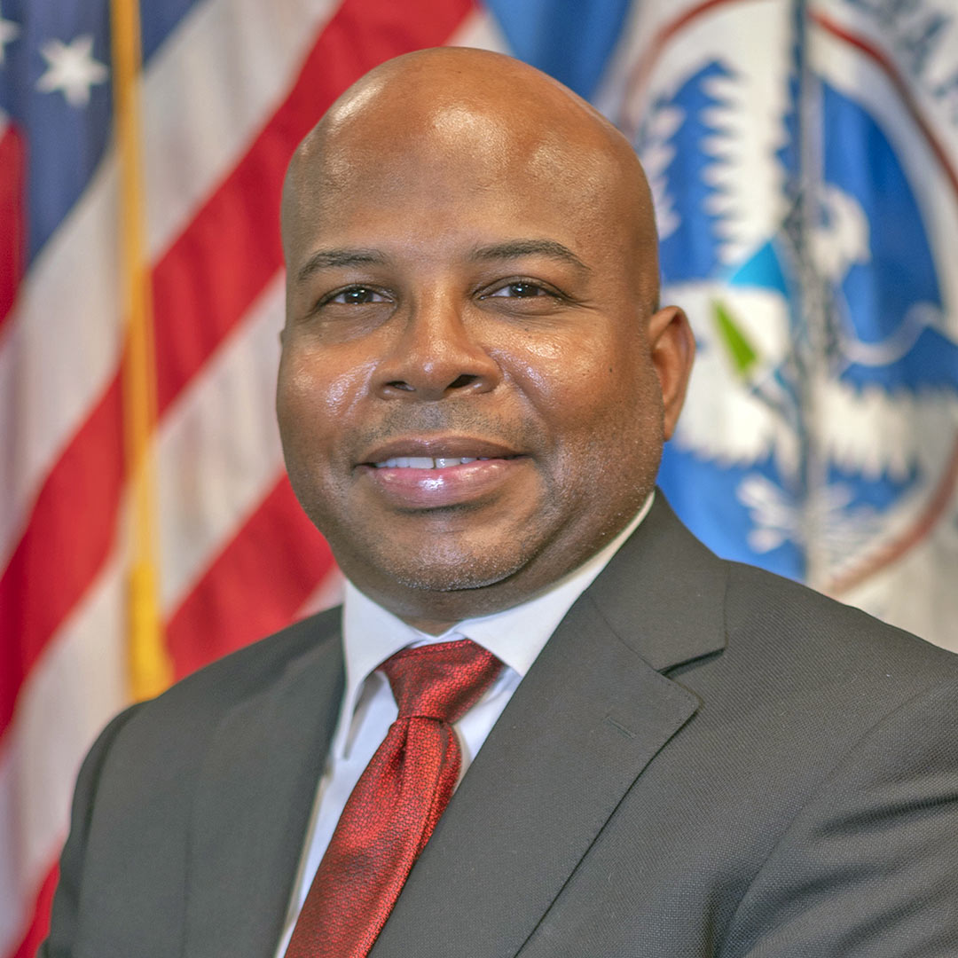

Sherman Gillums, Jr., Ed.D, serves as FEMA’s disability coordinator and the director of its Office of Disability Integration and Coordination (ODIC), located in the agency’s Washington D.C. headquarters. In his role, Sherman advises FEMA Administrator Criswell on meeting the agency’s commitment to equity in emergency management for people with disabilities.

Since joining FEMA in August 2022, Sherman has deployed to six disasters and led the national-level public narrative for people with disabilities on nearly a dozen emergency response efforts, in his capacity as the agency’s lead advisor on disability integration. In March 2023, Sherman released to the FEMA workforce his Director’s Intent, “A Guide to Meeting the Disability Integration Mission.” The vision focuses on 14 potential points of inequity and a pre-landfall risk assessment that can substantially extend the disaster lifecycle for people with disabilities and older adults.

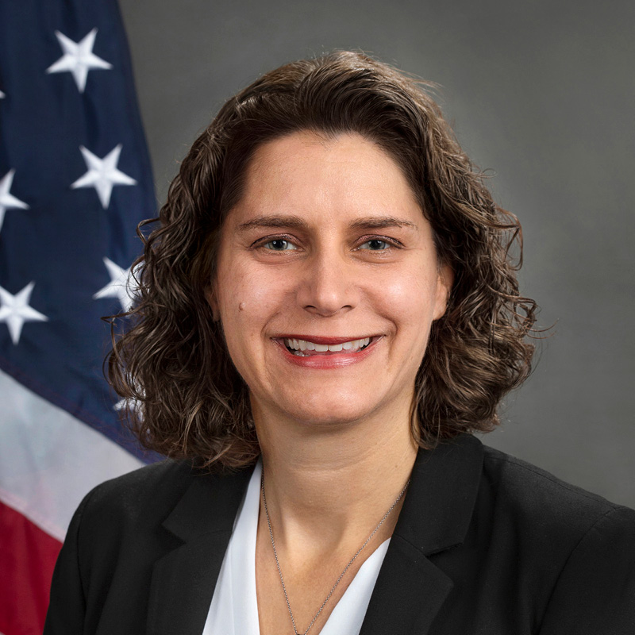

Alison Barkoff (Closing Plenary)

Alison Barkoff was sworn in as Principal Deputy Administrator on January 20, 2021 and is currently performing the duties of the ACL Administrator and the Assistant Secretary for Aging. She provides executive leadership and coordination for ACL programs nationwide and advises the HHS Secretary on issues affecting people with disabilities and older adults.

As part of countless coalitions of people with disabilities, older adults, and advocates, she has fought to uphold the rights of people with disabilities and older adults and advance policies to ensure their access to health care, housing, employment, education, and all other facets of community life. She has testified before Congress and the US Commission on Civil Rights on disability rights and community living. She has served in a variety of leadership roles with disability rights organizations, including leading advocacy efforts at the Center for Public Representation and the Bazelon Center for Mental Health Law.

Annual Council Meeting Agenda

Tuesday, July 23, 2024; 2:15–3:00 p.m. Eastern

Independence Ballroom; Grand Hyatt Washington

Please note: times outlined below are estimated and may occur earlier or later than stated in the agenda.

2:15 p.m.
Call to Order & Welcome
Kent Crenshaw

2:20 p.m.
Review of Nomination & Election Procedures
John Herring

2:25 p.m.
Announcement of Elected Executive Committee Positions
John Herring

- Vice-President
- Secretary
- DEAI Chair

Announcement of Member At-Large Positions

3 Elected Positions

Announcement of Youth Member At-Large Position
- 1 Elected Position

Announcement of Elected Regional Representative Positions

- Regions 2, 4, 6, 8, 10

2:30 p.m.
Reports

A. President
Kent Crenshaw

B. Executive Director
Theo Braddy

C. Vice President
Jeff Hughes

D. Secretary
John Herring

E. Treasurer
Jeremy Morris

2:45 p.m.
Acknowledgement of NCIL’s Committees and Subcommittees
Jeff Hughes

2:55 p.m.
- Old Business
- New Business
- Announcements
Kent Crenshaw

3:00 p.m.
Adjournment

Map of Independence Level (5B)

An enlarged map of Independence Level is available in Independence Foyer.

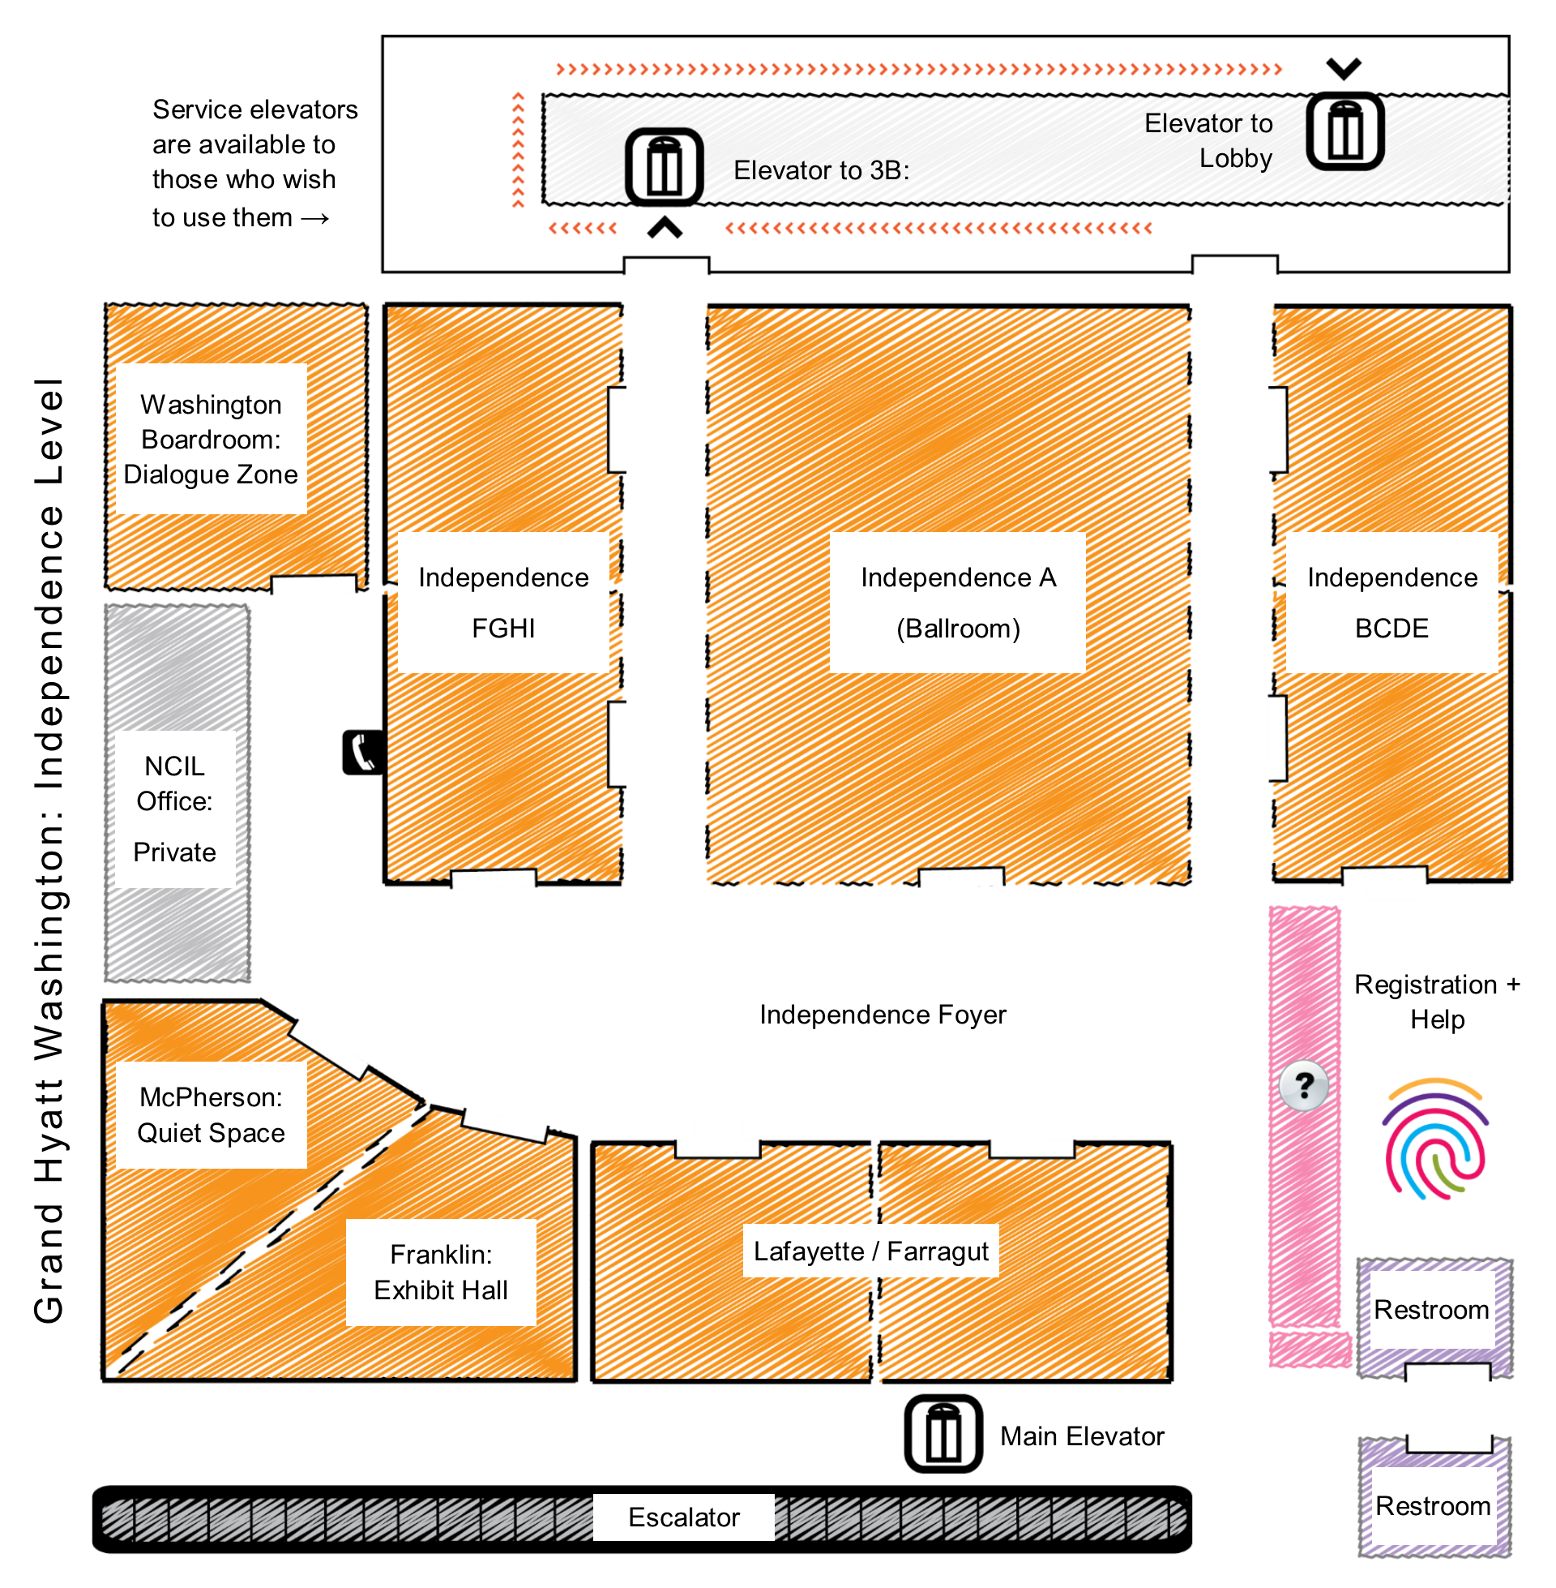

Restrooms

All restrooms on Independence Level (5B) will be gender inclusive for the duration of the conference. Additional restrooms are available on Declaration Level (1B) and Constitution Level (3B).

Health & Safety Protocols

By attending the 2024 Annual Conference on Independent Living, you agree to abide by and engage in certain health and safety protocols while attending the conference sessions. Please note, these may be adjusted depending on the current public health environment.

MASKS

Masks are encouraged, but will be optional this year, pending any unforeseen events. Please plan to bring your own mask if you would like to wear one. If you have any questions regarding the new protocols, please reach out to jenny@ncil.org.

SOCIAL DISTANCING

Social distancing will be practiced at all Annual Conference activities.

Onsite Registration

- NCIL Member: $350
- Non-Member: $450
- Youth (26 or younger): $150
- Daily Rate - NCIL Member: $130 / day
- Daily Rate - Non-member: $175 / day
- Luncheon Ticket: $75 (included in Tuesday’s Daily Rate)

Personal Assistant Registration Policy: Personal Assistants are not required to pay the registration fee but should fill out a form to receive a badge. Personal Assistants are welcome to attend all conference events, including scheduled meals and receptions.

Meals

Your ticket to the Luncheon is your name badge. Unregistered guests may purchase luncheon tickets for $75.

NCIL Regions by State

Region I (1): Connecticut, Maine, Massachusetts, New Hampshire, Rhode Island, Vermont. Region I Representative: Steve Higgins.
Region II (2): New Jersey, New York, Puerto Rico, Virgin Islands. Region II Representative: Aaron Baier.
Region III (3): Delaware, District of Columbia, Maryland, Pennsylvania, Virginia, West Virginia. Region III Representative: Vicki Landers.
Region IV (4): Alabama, Florida, Georgia, Kentucky, Mississippi, North Carolina, South Carolina, Tennessee. Region IV Representative Edward Mitchell.
Region V (5): Illinois, Indiana, Michigan, Minnesota, Ohio, Wisconsin. Region V Representative: Vacant.
Region VI (6): Arkansas, Louisiana, New Mexico, Oklahoma, Texas. Region VI Representative: Samantha Moreno.
Region VII (7): Iowa, Kansas, Missouri, Nebraska. Region VII Representative: Vacant.
Region VIII (8): Colorado, Montana, North Dakota, South Dakota, Utah, Wyoming. Region VIII Representative: Tami Hoar.
Region IX (9): Arizona, California, Hawaii, Nevada, American Samoa, Guam, Northern Mariana Islands, Trust Territory of the Pacific Islands. Region IX Representative: Lisa Hayes.
Region X (10): Alaska, Idaho, Oregon, Washington. Region X Representative: Kimberly Meck.

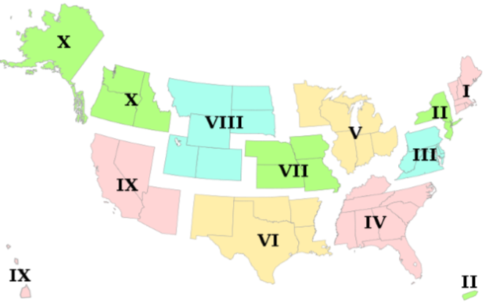

Do-It-Yourself Sign Kits

Complimentary Do-It-Yourself Sign Kits will be available on the conference floor the morning of Monday, July 22. Please take the kit back to your room and use it to create your signs for the Rally on Monday. Feel free to be creative. Some examples include:

- 5 FOR 5: FUND CENTERS FOR INDEPENDENT LIVING!
- Disability Is a Natural Part of the Human Condition
- I ❤ INDEPENDENT LIVING
- Free Our People / Institutionalization Is No Way to Live
- Disability Rights Are Civil Rights #NCIL2024
- Don’t Roll Back Our Rights!
- ADA: Making the Dream Live for ALL
- Nothing About Us Without Us
- Full Community Integration Now
- Employment = Empowerment
- Equality Now! America for All
- Justice Delayed is Justice Denied
- Our Homes Not Nursing Homes! #FreeOurPeople
- ADA: I Am Equal Too
- Civil Rights Are Not Special Needs
- The Future is Accessible
- Access is a Civil Right
- Cure Ableism #CheckYourPrivilege
- Disability Power! #DisabilityPride
- Disabled People Vote #CripTheVote
- Justice Not Just Us
- People Over Profits

What to Bring

Remember to bring along the following items to ensure your comfort and safety:

- attire appropriate for both very hot and chilly temperatures;
- repair equipment / tools for your devices; and
- any medications or assistive devices you may need during strenuous activity.

Access, Accommodations, & Resources

Environmental / Chemical Sensitivities

Fragrances and chemicals can be barriers to access. To help make this Conference accessible to participants for whom chemicals or fragrances are an access barrier, NCIL requests that you come fragrance free. Please refrain from wearing any scented products or washing with them. This includes clothing that has been laundered with fragranced detergent or fabric softening products. Additionally, please completely air out any dry-cleaned clothing before wearing it to the Conference.

Smoke can also be an access barrier. It is essential that we maintain a smoke-free environment. If you smoke, please use the designated smoking area located outside the Hyatt. Please refrain from smoking near any other doorways or paths of travel. The hotel entrance at 11th Street should be the least polluted with cigarette smoke and vehicle exhaust, although it unfortunately has steps.

Parking

The maximum vehicle height for the garage at the Grand Hyatt is 6’ 6”. Taller vehicles (up to 8’ 2”) may park in the City Center complex, directly across the street from the Grand Hyatt. City Center offers an overnight parking rate of $24 / night, which is less than the rates at the Grand Hyatt.

Sensory Retreat / Quiet Room

The McPherson room will be available throughout the Conference as a sensory retreat. This room is reserved for individuals that need a break from overstimulation and / or the large group environment of the Conference. Please help us maintain this accommodation. Do not use this space to hold conversations or meetings. Washington Board Room is available as a dialogue zone.

Auxiliary Aids & Services

CART captioning, sign language interpreters, assistive listening devices, personal assistants, accessible materials, and other services will be provided for all Conference activities. However, participants must arrange their own services for Hill Visits. Congress is responsible for providing interpreters for Hill Visits upon request. Email contact: interpreters@saa.senate.gov.

Local Service Providers: Personal Assistant Services

NCIL’s Personal Assistants will be available during conference hours only. NCIL’s personal assistants are only to be used for basic tasks. If you need more assistance than basic tasks, you will be required to bring your own personal assistant. Personal assistants may attend all conference activities free-of charge but should register to receive a name badge. Use the information below to arrange your own personal assistant service during non-conference hours.

Right at Home Washington DC

- Phone: 202-269-0008 / Contact form: https://www.rightathome.net/dc/contact

DC Health Home Care Agency Directory (PDF): https://bit.ly/3z3NBFw

Local Service Providers: Wheelchair and Scooter Rental and Repair

ZASK Medical Supply - Alexandria, VA

- Phone: 703-354-1266 / Email: info@zaskmedical.com

ScootAround (Rentals only. Delivery available.)

- Phone: 1-888-441-7575 / Website: scootaround.com

Express Mobility Services

- Phone: 703-346-8796 / Website: expressmobilityservices.com

Scooterplus / Lenox Medical Supply (Rentals only. Delivery available.)

- Phone: 1-866 474-4356 or 202-387-1960 / Website: lenoxmedicalsupply.com

Advocate’s Guide to the Hill

Each year, the highlight of the NCIL Annual Conference is the convergence of members from across the nation, who unite on Capitol Hill to share stories of discrimination, institutionalization and segregation with their Senators and Representatives.

Rally Site

The Rally will take place at the US Capitol in Area 12, next to the Reflecting Pool on Monday, July 22; 4:00 – 5:00 p.m.

Hill Day

Wednesday, July 24 has been set aside for NCIL’s Hill Day. NCIL members are strongly encouraged to go and meet with their elected officials (or set up virtual meetings where necessary) to discuss pressing issues. These meetings must be arranged in advance. Senators and Representatives set their own policies about whether they are meeting with constituents in-person or virtually. When scheduling meetings, ask about any COVID protocol or practices that are required so that you can be prepared. The public spaces within the Grand Hyatt can be utilized for in-person meetings with elected officials and their staff for those needing a meeting space outside of the Capitol.

Getting to the Capitol

Directions from the Grand Hyatt Hotel to Area 12, next to the Capitol Reflecting Pool:

- Depart 11th & G Streets NW.
- Travel 2 blocks East on G St. NW.
- Turn Right on 9th St. NW, travel 3 blocks South.
- Turn Left on Pennsylvania Ave. NW, travel 4 blocks SE.
- Proceed to Area 12 of the US Capitol Grounds, immediately North of the Capitol Reflecting Pool.

The metro stations at Union Station and South Capitol are located just a few blocks away from the House and Senate office buildings. Union Station is to the North, closest to the Senate office buildings. Capitol South is located to the South, closest to the House office buildings.

Cabs are also readily available near the U.S. Capitol. A limited amount of wheelchair accessible Uber vans are also available in DC. For more information: uber.com/ride/uberwav.

About Your Visit to Capitol Hill

Security Notice: In order to meet with your elected official, you will have to pass through a security screening in all House and Senate office buildings. You are encouraged to bring photo ID with you on your Capitol Hill Visit.

You will be required to pass through a body scanner. If you are unable to be scanned or uncomfortable, please request a pat down or wand screening.

All bags are subject to thorough search and security screening. If you have any of the following items with you on your visit to Capitol Hill, you may not be allowed to visit your representative. Prohibited items include:

- Mace and pepper spray
- Any sharp or pointed object
- Knives of any size, including pocket knives
- Cans and bottles
- Any bag larger than 14" wide x 13" high x 4" deep (per security discretion)
- Weapons of any kind
- Non-aerosol spray
- Aerosol containers
- Signs

This is an abbreviated list. If in doubt, leave it at the hotel!

Tunnels

Both the Senate and the House Office Buildings are connected by underground tunnels. Once you pass through security to either the Senate or the House Office Buildings, you can move about freely between buildings of that office without having to repeatedly go through security. The interconnecting tunnels can be found in the basements of both the Senate and House Office Buildings.

Map of Rally Site

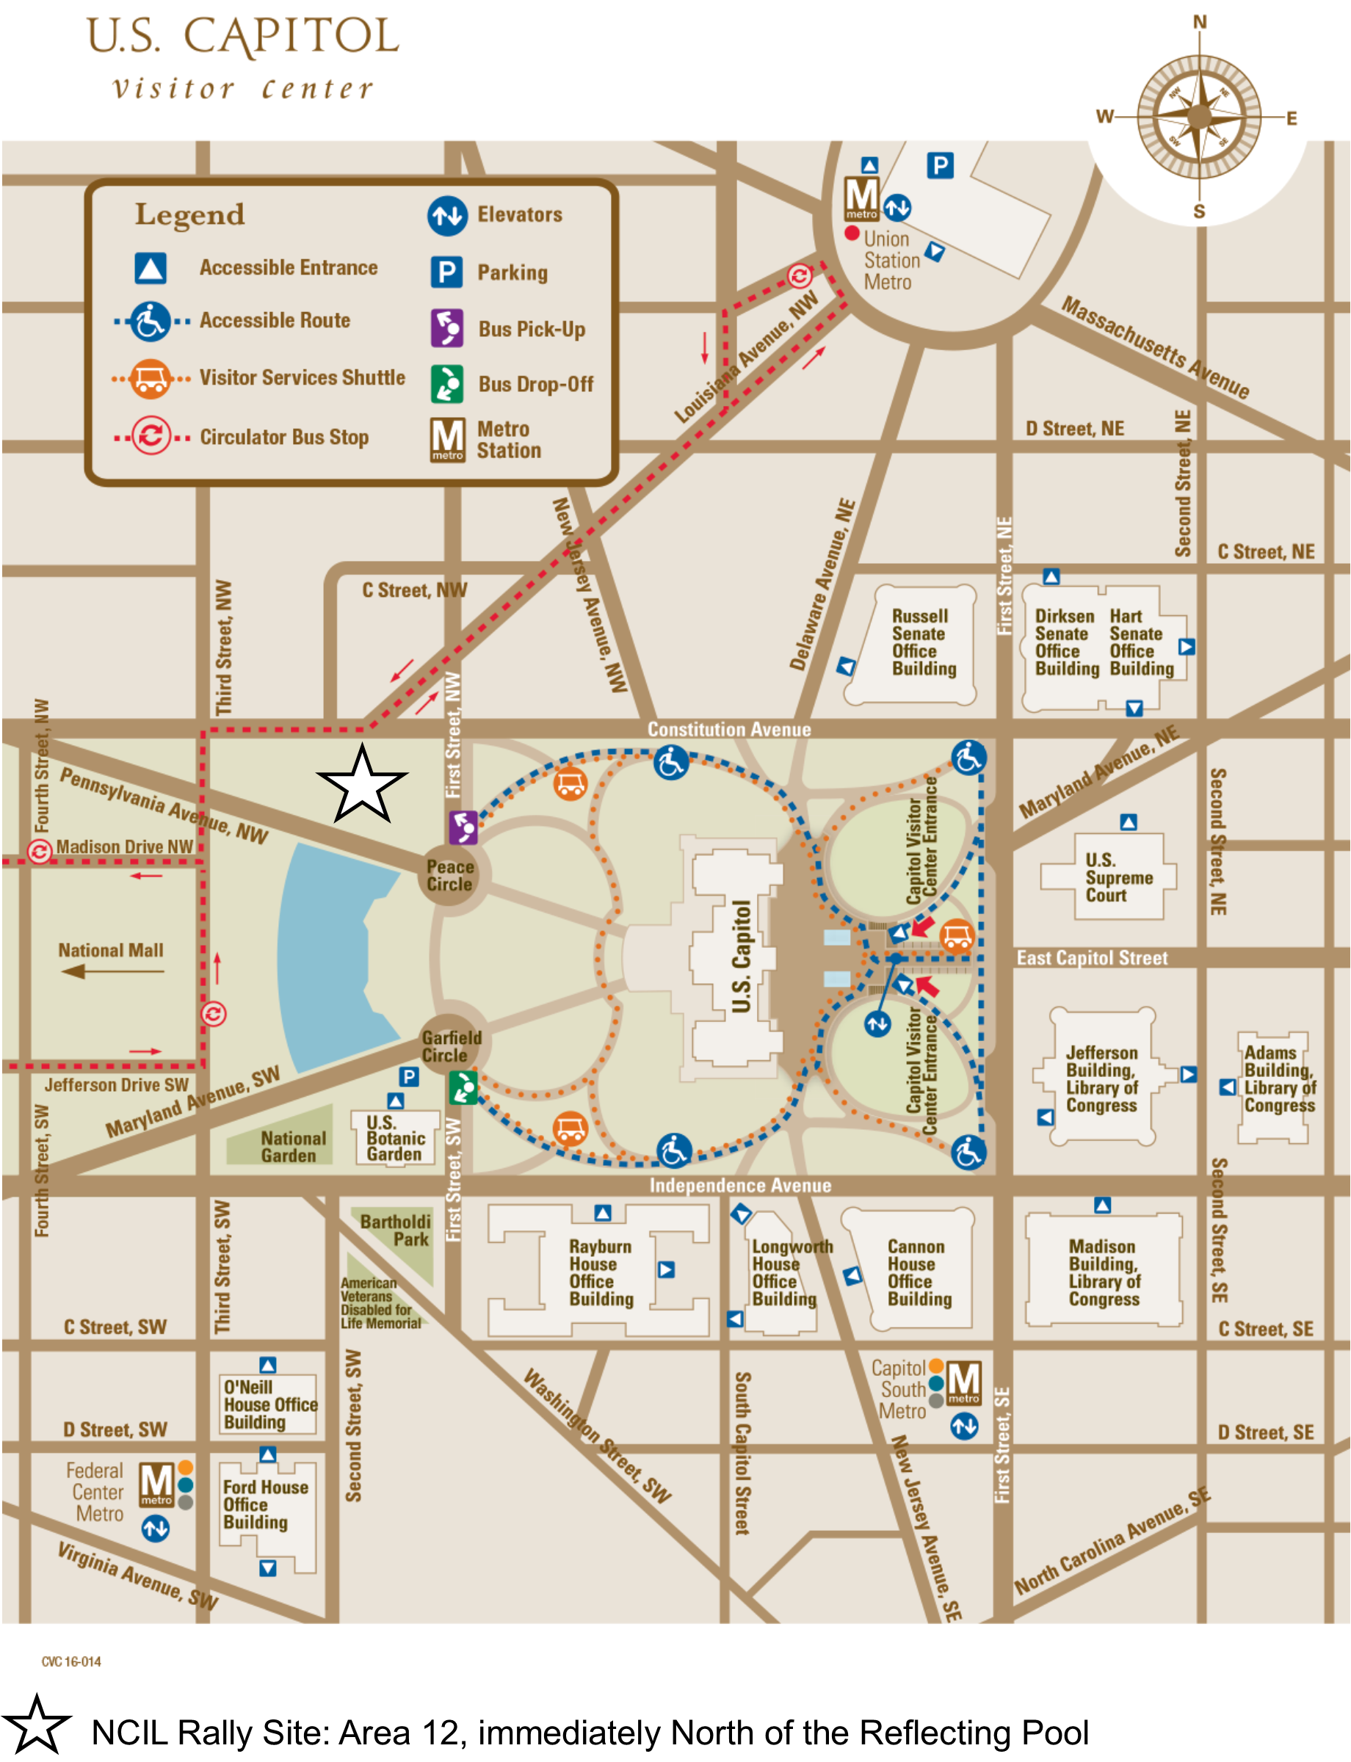

Accessible Entrances

- Capitol Building: Public tours enter through the Capitol Visitor Center; Official House business enters on the south side of the Capitol; Official Senate business enters on the north side of the Capitol.
- Capitol Visitor Center (CVC): Main entrance at First and East Capitol streets. The CVC also offers an on-demand shuttle and other services.
- Cannon House Office Building: Entrance on New Jersey Avenue, SE, south of the terrace at the intersection with Independence Avenue.
- Dirksen Senate Office Building: First and C Street entrance.
- Ford House Office Building: Entrance on 3rd Street, SW or 2nd Street, SW.
- Hart Senate Office Building: Second Street entrance or Constitution Avenue entrance.
- Longworth House Office Building: Main entrance, Independence and New Jersey Avenues. Or the South Capitol Street entrance.
- O'Neill House Office Building: C Street SW between 2nd and 3rd Streets.
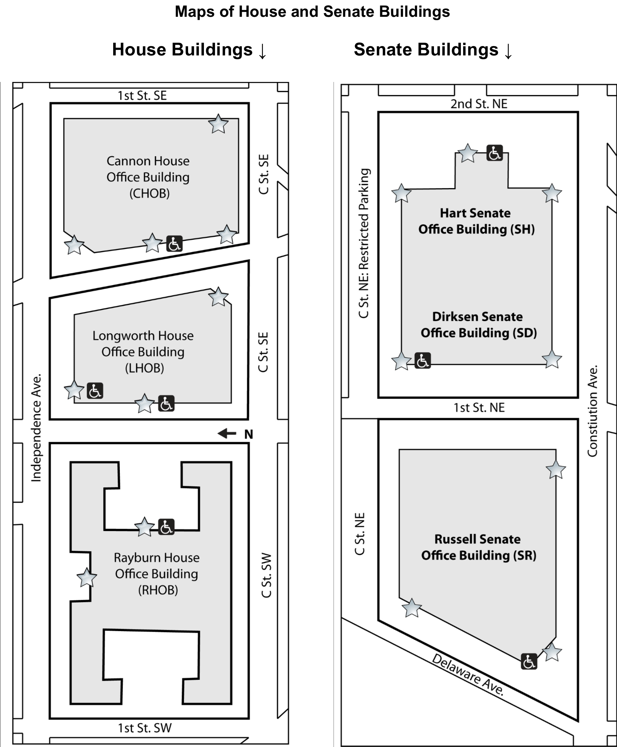

Hill Cafeterias

Have some down time in between appointments once you are in the House or Senate Office Buildings? Both offer a number of places to have everything from a quick snack, to a full meal. For more specific information on directions to tunnels, eateries, or to your Representative’s office, feel free to ask Hill staff or security. Please note that only water is being provided at this year’s Rally.

Senate Office Buildings:

- Russell Basement: Coffee and Sandwich Shop
- Dirksen Basement: Full Cafeteria - Your best bet on the Hill!

House Office Buildings:

- Longworth Basement: Cafeteria
- Rayburn Basement: Coffee and Sandwich Shop

There is also a cafeteria located inside the U.S. Capitol Building.

Services on Hill Visits

CART (Communications Access in Real Time), sign language interpreters, assistive listening devices, personal assistants, accessible materials, and other services will be provided upon request for all NCIL conference activities. However, participants must arrange their own services for Hill Visits on Wednesday, July 24. Congress is responsible for providing interpreters for Hill Visits upon request. The following email contact is provided by the Capitol Visitor Center: interpreters@saa.senate.gov.

Directories of the 118th Congress: Second Session

Directory of the Senate: To contact your Senator, use the directory at: senate.gov/senators/contact. Senators are listed alphabetically with their phone numbers, email addresses, and office locations available. You may also find information by calling the Capitol Switchboard at 202-225-3121 or 202-224-3091 (TTY).

Your Senator’s office will be in one of three “Senate Office Buildings” or SOB. They are Dirksen, Hart, and Russell. The room number of your Senator coincides with the floor his or her office is on. If your Senator is located in Hart 302, that office is on the 3rd floor; Dirksen 439, is on the 4th floor; Russell 238 is on the 2nd floor.

Directory of the House of Representatives: To contact your Representative, use the directory at: house.gov/representatives. Representatives are listed alphabetically with their phone numbers, email addresses, and office locations available. You may also find information by calling the Capitol Switchboard at 202-225-3121 or 202-224-3091 (TTY).

Your Representative’s office will be in one of three “House Office Buildings” or HOB. They are Cannon (CHOB), Longworth (LHOB), and Rayburn (RHOB). The room number of your representative coincides with the floor his or her office is on. If your representative is located in Cannon 328, that office is on the 3rd floor. If the office number is more than three digits, disregard the first number and the second number represents the floor your representative’s office is located on. For example, an office listed as Rayburn 2439, is on the 4th floor; Longworth 1721 is on the 7th floor.

Additional Resources

For more help with planning your visit to the Capitol please visit the Capitol Visitor Center's website: visitthecapitol.gov/plan-visit/visitors-disabilities.

Sponsors

Champion for Justice

Centene

Hero

CareSource
Nevada Statewide Independent Living Council

Leader

Dignity Memorial
Waymo
Verizon

Catalyst

Esquire Bank
UnitedHealthcare
Airbnb
CIL Suite
ADA National Network
PhRMA
Cruise

Donors: Amazon ·American Association on Health and Disability (AAHD)

Advertisements

The Coalition for Disability Rights and Justice: THE COALITION FOR DISABILITY RIGHTS AND JUSTICE: ADA Watch Logo. Graphic features a torch. National Coalition. Disability Rights Concerts. Road To Freedom Bus Tour. Campaign for Fair Judges. Alliance of State Disability Coalitions. How You Can Help! Sign Up For News & Updates! https://adawatch.nationbuilder.com/subscribe. Take Action in the ADA Watch Action Center! https://adawatch.org/action-center/. Support Our Work! https://www.flipcause.com/secure/cause_pdetails/MTg2NjQ4. We work to AMPLIFY the voices of the Disability Rights Movement! Email: info@cdrj.org I Website: ADAWatch.org.

Cruise: Building the world's most advanced autonomous vehicles. We are proud to work with and support the National Council on Independent Living. Learn more at GetCruise.com/accessibility. Image: A white Cruise-branded CRV.

Esquire Bank: Esquire Bank is proud to support the National Council on Independent Living. Logo: Esquire bank. Succeed Boldly. 844-ESQ-BANK. esquirebank.com. Member FDIC LENDER. Image: A man using a manual wheelchair bites the ear of his glasses while holding a laptop in his lap.

ADA National Network: Logo: ADA National Network – Information, Guidance, and Training on the Americans with Disabilities Act. Questions about the Americans with Disabilities Act? WE HAVE ANSWERS! 1-800-949-4232 (V/TTY). Find the nearest ADA Center in your area by visiting www.adata .org.

Centene Corporation: Centene is proud to sponsor the 2024 NCIL Conference, bringing together and building the diverse network of the independent living movement. CENTENE.COM. Blue background with abstract wave shapes comprised of dots.

Dignity Memorial: Committed to providing compassionate care. Proud to support the National Council on Independent Living Annual Conference. DignityMemorial.com/Grief. Logo: Every detail remembered. Logo: Dignity Memorial. Find your local provider at DignityMemorial.com. The Dignity Memorial brand name is used to identify a network of licensed funeral, cremation and cemetery providers owned and operated by affiliates of Service Corporation International, 1929 Allen Parkway, Houston, Texas, 77019. Copyright 2024 SCI Shared Resources, LLC.

American Dream Employment Network: Logo: American Dream Employment Network. Graphic features a sun and sunbeams. The American Dream Employment Network (ADEN) invites you to explore becoming an employment service provider under the Social Security Ticket to Work Program. Learn how Administrative Employment Networks (EN) can help you succeed in serving SSA disability beneficiaries, creating an ongoing revenue stream for your agency. Join us for a free webinar: Introducing the American Dream EN (https://bit.ly/3xb4hKQ) Wednesday, 8/7/24; 1:30-2:30 PM ET. Icon: computer: AmericanDreamEN.org. Icon: info@AmericanDreamEN.org. ADEN is a national administrative Social Security approved Ticket to Work service provider and a division of National Disability Institute. Logo: Ticket to Work – Social Security Administration. Image: a woman engaged in conversation with another person.

UnitedHealthcare: Logo - UnitedHealthcare: a stylized letter ‘u’. Helping people live healthier lives. UnitedHealthcare Community & State is proud to support the National Council on Independent Living Annual Conference. uhccs.com. UnitedHealthcare: There for what matters.

CareSource: Reimagining Health Care. Inclusion | Equity | Independence | Advancement. Text: Caresource is a proud partner and sponsor of the 2024 Annual NCIL Conference. Image: CareSource Logo. Image: a person using a wheelchair smiles in an artistic work environment. Image: a person smiles in a technical work environment.

Waymo: Waymo Logo features a blue and green letter w. www.waymo.com. Moving forward, together. Waymo is proud to support NCIL. A Waymo vehicle with technology attached to the roof is surrounded by five concentric circles and three people, including one person with a prosthetic leg and one person with a white cane and service dog.

